Audible Reckoning: The Role of Political Podcasters in Perpetuating Post-Truth Politics

In February 2021, Texas Senator Ted Cruz and his co-host Michael Knowles, a *Daily Wire* commentator, recorded a live episode of *The Verdict with Ted Cruz* podcast*.*[1]In conversation about Beto O’Rourke, the Texas Republican described his rival's support base as primarily reporters who act like “groupies at a Rolling Stones concert throwing their underwear.” Offhandedly, he added, “I mean if they wore underwear.” With a smirk, he leaned into the microphone and asked Knowles, “Too edgy?” Knowles replied, “It’s a podcast you can say whatever you want!”

Since the advent of the medium, podcasts have generally offered a space where, in the words of Knowles, 'you can say whatever you want.' In recent years, this freewheeling approach has become increasingly popular. Once written off as a “dying medium,” podcasting has undergone rapid expansion and monetization, while remaining outside of content moderation and regulatory debates. Today, nearly 41% of Americans listen to podcasts monthly, and one in four Americans now look to podcasts for their news. Globally, the medium is predicted to reach an audience of 504.9 million by 2024, while ad revenue in the U.S. is expected to double during the same period, jumping from $2 billion to $4 billion.[2]

Due in part to the “say whatever you want” perceptions of the medium, podcasting offers critical avenue through which unsubstantiated and false claims proliferate-- claims which, evidence suggests, have played a vital role in shaping public opinion and political behavior.[3]Despite these risks and despite its growth in the market, the podcasting ecosystem and its role in political debates has received little attention.[4] The reasons for this oversight are diverse, ranging from the technical challenge of analyzing multi-hour, audio-based content to misconceptions of the medium.[5] As a result, understanding the scope of this challenge is critically important.

Using a variety of technical tools, including natural language processing and machine learning, this research aims to fill this gap by offering the first ever overarching assessment of popular political podcasting’s role in shaping post-truth politics. Drawing on data from 36,603 episodes from 79 prominent political podcasters, 17,046 fact checks, and 185 key terms and phrases, I document the spread of unsubstantiated and false claims across the political podcasting ecosystem from late 2012 and into early 2022. I find that:

* More than 1 out of every 20 episodes (>5% of all episodes) in the dataset promoted at least one unsubstantiated or false claim.
* Nearly 70% of all podcasters have shared one or more unsubstantiated or false story, as compared to 8.5% of the general public’s sharing patterns on Facebook.[6]
* Taking into account the partisan bent of fact checked claims, conservative podcasters were still 10 times more likely to share unsubstantiated or false content fact checked by external fact checkers than liberal podcasters.
* The ten podcasts that share the most unsubstantiated and false claims, measured as a percentage of total episodes, have a combined audience of more than 28 million on Facebook and Twitter

Across the medium, I also find that political podcasters are promoting unsubstantiated or false health and election-related claims. However, the tenor of this content varies dramatically. In the lead up to the January 6th attack on the U.S. Capitol, prominent political podcasters played an overt, central, and partisan role in disseminating election fraud narratives and sowing doubt about the security of the elections. By comparison, unsubstantiated or false pandemic-related claims spread by political podcasts tended to be less overtly partisan, and ebb and flow with key moments during the pandemic, with little obvious change resulting from a shift in the political leadership driving the pandemic response.

To strengthen the information ecosystem across the podcasting industry, tech companies, regulators, listeners, and hosts all have a role to play. Greater transparency about content moderation practices, financial relationships between hosts and sponsors, and algorithmic amplification by podcasting apps would significantly improve what has so far been an opaque medium. Enhancements to the app architecture, such as improved reporting procedures and room for audience participation, would not only create a richer information environment but effectively incorporate the “crowd” as a vital contributor to the conversation. Due to the decentralized nature of the podcasting ecosystem, these types of adjustments will not lead to a complete overhaul of the medium, but they will go a long way toward improving a space that has until recently received little attention, despite its growing influence in political conversations.

# 1. The Evolution of the Podcasting Medium

In 2004, journalist Ben Hammersley reported on a “new boom in amateur radio,” where he mused about what to call this new space.[7] “Audioblogging? Podcasting? GuerillaMedia?” he suggested, perhaps not realizing that he was coining a term for a now multi-billion-dollar industry.[8] At the time, the term described audio content that could be played on demand through any MP3 device, like the increasingly popular iPod.[9] This new world allowed listeners to take their audio with them, pause it as needed, and start it again at their convenience.[10] This on-the-go capability stems from the fact that early adopters shared episodes through RSS feeds, which users could subscribe to directly or indirectly and download and listen to content.[11] The RSS architecture facilitated the growth of a decentralized, open-sourced medium detached from regulations and the limitations of terrestrial or digital radio. It was a medium where “anyone can be a publisher, anyone can be a broadcaster,” according to one of podcasting’s earliest pioneers.[12]

In the early to mid-2010s, true crime shows like *Serial* and non-fiction series like *This American Life* constituted the bulk of mainstream podcasting. In 2016, the medium expanded its scope into political punditry, in parallel to the U.S. presidential campaign and election of Donald Trump. According to data at the time, more than 1,000 political podcasts launched in the year after Trump took office, with most taking a liberal [13] Soon after, conservative talk radio hosts, YouTube personalities, and websites like *The Daily Wire* and *The Blaze* launched their own podcast offerings.

Today, series focused on politics and current events are among the most popular, and political punditry shows regularly feature in Apple’s Top 100 rankings.[14] Until early 2022, many of these shows were regularly categorized as “News” despite regularly veering into opinion programming that goes beyond the traditional definition of 'news'.

## Unsubstantiated and False Claims in Podcasting

Combining elements from radio and social media, podcasting has the potential to operate as the perfect storm for the proliferation of unsubstantiated and false claims. Like Twitter, Facebook and other social media sites, the barriers to entry for podcasting are all but eliminated. Like radio, listening to a podcast—due to its auditory nature—can foster a level of trust and intimacy between host and audience in a way that a passing tweet may not. As a result, on podcasting, anyone can become a trusted armchair expert on a subject of their choosing, regardless of their credentials.[15]

Furthermore, on social media, commenting or retweeting may serve as a check on the spread of false or misleading claims because people may fact check these claims through their engagement. In podcasting, an audience check on the proliferation of unsubstantiated or false claims is not possible. Instead, the dynamic resembles a monologue, more like television or radio. Audiences are unable to directly react to or share their thoughts about an episode, making it easier for false content to spread with little oversight.

But unlike radio, listening to a podcast is also more of a deliberate and decentralized act.[16] The downloadable nature of a podcast episode means that a listener can begin and pause that episode whenever they want. The medium is also hosted exclusively on the internet and available across a wide variety of applications, including as a simple .mp3 file. As a result, it offers a far more decentralized--and diverse--distribution mechanism than radio, making it far more difficult to implement uniform content moderation guidelines.

Despite the clear potential for unsubstantiated or false claims to spread through podcasts, the medium has until recently been overlooked by researchers. The audio-based nature of the medium, which regularly features hours-long episodes, makes it difficult to monitor the ecosystem given existing research strategies, which frequently rely on URL-based content to identify domains deemed “low-quality” by expert sources.[17] Fortunately, natural language processing techniques provide useful tools for assessing non-URL based content, but these strategies require transcriptions of hours of content, which, until recently, could be prohibitively expensive.[18] When transcripts are available, evaluating their content at scale is still a challenge -- searching for a small claim within hours of text is like searching for a needle in haystack.

A misunderstanding of the medium by those best equipped to investigate it may also explain the limited attention paid to podcasting. Although the potential for episodes to “go viral” -- or spread rapidly across the digital information ecosystem -- on popular podcasting apps is unlikely, podcasters often have broad cross platform appeal, making their content likely to reach large audiences. Furthermore, the intimacy and authority attached to the relationship between podcaster and audience may make unsubstantiated or false claims shared in this medium far more impactful than a passing viral tweet from a potentially anonymous account.[19] And although podcasting is certainly home to prestige series, it has since expanded to new niches, including the political punditry space, where hosts from a variety of backgrounds offer regular, often highly polarizing commentary on current events.

# 2. Data and Research Methodology

To conduct the analysis detailed in subsequent sections, I collected all episode data available through podcasters’ RSS feeds. I then utilized Azure’s Speech-to-Text model to transcribe .mp3 files downloaded from the RSS feed.[20] These transcriptions, along with captions from select episodes transcribed by YouTube’s Data API, form the basis of this analysis.[21] Although the transcription services occasionally struggle to correctly transcribe some proper nouns (for example, the name Anthony Fauci), in general, the transcriptions collected are well suited for the natural language processing methods utilized in this analysis. Where transcription errors do occur, these would likely lead to false negatives – i.e., an undercount of these claims – due to an inability to detect word matches and word or phrase similarities.

In total, I collected data for 36,603 episodes across 79 series, identified systematically through a sampling process detailed below. When possible, I collected the entire series catalogue, however the data is limited to what podcasters shared on their RSS feeds or provided on their YouTube channels at the time I finalized data collection in January 2022. An overview of this data, including the total number of episodes by month over time and total number of episodes per series, is included in **Figure 1** and **Figure 2**, respectively.

**FIGURE 1**



**FIGURE 2**



As is evident, the podcasting medium has exploded in recent years (Figure 1), though some podcasters are far more prolific than others (Figure 2). The podcast Bannon’s War Room, which began in October 2019, publishes up to four episodes per day, 5 to 6 days a week. Other shows, like Pod Save America, which began in January 2017, publish new content around two times a week. Thirteen series in the dataset have recorded over 1,000 episodes.

The shows featured in the dataset include both conservative, moderate, and liberal podcasters, as well as those to which I could not assign a political ideology.[22] However, the sample includes far more conservative podcasters than liberal ones, and even fewer moderate and unknown series. According to Figure 3, conservative podcast episodes are more than 4 times more common in the dataset; however, series with a conservative host are less than 2 times more common than series with a liberal host to appear in the dataset.[23] This is because conservative podcasters produce nearly three times as many episodes per series as liberal podcasters. On average, conservative podcasters produce 620 episodes a series while liberal ones only produce 275 episodes.

**FIGURE 3**

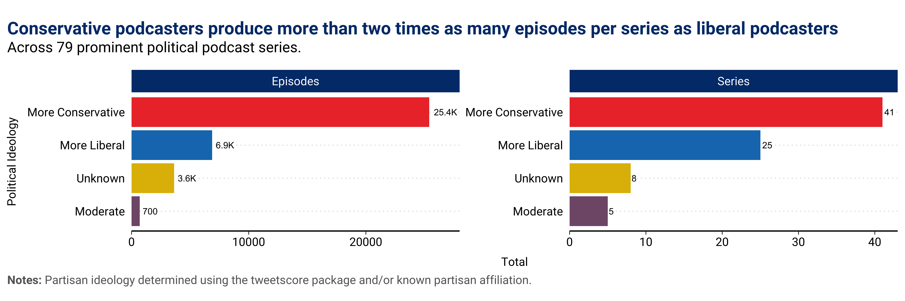

The decision to include more conservative political podcasters (or more conservative podcast episodes) in the dataset was not a deliberate choice, but rather a function of how popular these series are across the medium and how likely they are to be recommended by Apple. To develop the sample of popular political podcasters, I relied on two Apple Top 100 lists – the first from mid-November 2020 (just after the 2020 election) and the second from mid-April 2021 (in the middle of the coronavirus pandemic). As a first step, I pulled all “talk-show” style series from two Top 100 lists that use the words “policy,” “politics,” “current events,” or “news” in their description *or* at the time of data collection featured recent episodes discussing political topics. As a next step, I identified any political punditry podcasts from the “You Might Also Like” section in the Apple Podcast app for shows selected through the prior step and following the same criteria for selecting shows about political topics. Through this process, I avoid cherry-picking series that reinforce my own biases and create a corpus of series identified in a systematic way. For a full overview of the dataset by series, see Appendix 2.

Because data on series and episode reach and reception is largely unavailable, I supplemented this data with additional information collected from other locations. Where possible, I rely on Twitter and Facebook followers of hosts and/or series as a proxy for reach.[24] In the dataset, the average podcaster has 1.6 million followers on Facebook and 2 million followers on Twitter, suggesting a wide reach for these shows. As a measure of a show’s reception, I draw on data from Apple Podcast reviews, using both the star rating (from one to five) and the sentiment of the review text, calculated using VADER, as a measure of audience reaction.[25]

## 2.1 Classifying Unsubstantiated and False Claims

For many of the reasons detailed above, identifying and classifying unsubstantiated or false claims in podcasting is a challenge. Due to the vast amounts of content, searching for specific claims and understanding the intention behind sharing the claims (e.g., endorsing or refuting it) can be difficult. To overcome these obstacles, I utilize a variety of natural language processing techniques to identify specific parts of episodes that match unsubstantiated or false claims. These claims are compiled in two different ways: (1), the text of a claim or statement, fact checked by PolitiFact or Snopes; and (2) a dictionary built using qualitative knowledge and news reports of misleading claims tied to both election integrity and the coronavirus pandemic.

*Cosine Similarity Approach using Fact Checked Text*

To identify unsubstantiated or false claims in podcast episodes, I rely on a text similarity measure called the “cosine similarity,” a measurement technique that calculates the relationship between two documents (or text snippets) by encoding each document as a vector, with each word of the document representing a coordinate in the vector. The 'cosine similarity' is then calculated using the cosine of the angle between the two vectors.[26] The resulting output is a score from 0 to 1, with a higher number representing a more similar text. The challenge with this method for podcasting is that the documents are extremely unequal in length, which would make any vector comparisons difficult. On average, the fact checked claims are 17 words, whereas the transcripts are 9,734 words. As a result, I devised a strategy to scan through the entire transcript using text “windows” at a length that is 1.3 times the length of a fact checked claim. I use a slightly expanded window to allow for similar but not identical texts to be identified in the transcripts. Essentially, the strategy creates a moving window across the transcript, and calculates the cosine similarity across different windows of a transcript text until it reaches the end of the episode. I calculate the cosine similarity between every fact checked claim and all transcript windows, and only review matches that are above a .5, meaning the transcript window and fact checked claim are at least somewhat related.

The fact-checked claims used to scan transcripts come from PolitiFact and Snopes. Both sources provide exact quotes of unsubstantiated or false claims, which is ideal for the purposes of this analysis. For PolitiFact, I use claims rated as “Pants on Fire,” “False,” or “Mostly False.”[27] For Snopes, I use only fact checks categorized as “False,” “Mostly False” or “Scam.” In total, I scan transcripts for 11,082 PolitiFact and 5,974 Snopes fact checks. See Appendix 3 for more detail on these claims.

*Dictionary-Based Approach*

In addition to calculating the cosine similarity between transcript snippets and fact checked claims, I also developed a dictionary-based approach to evaluate claims tied to both the coronavirus pandemic and the 2020 election. A dictionary-based approach allows me to explore further misleading claims that the cosine similarity approach may not capture given its focus on leading political figures and more well-known conspiracies.

For both topics, I developed a dictionary of key words based on qualitative knowledge, existing research, a wide range of fact checks (including the Washington Post, AP, and Reuters), and general terms used by politicians and public commentators. I include each dictionary in the Appendix. I then searched transcripts of episodes for a list of keywords associated with different claims tied to either electoral fraud or the coronavirus pandemic, including both generic terms like “stolen election” and “phony pandemic” as well as references to specific conspiracy theories or misleading claims, such as “sharpies” or “microchip.”[28] This methodology means that it is unlikely the data includes false positives (i.e., instances where I coded a false or misleading claims when I should not have), but it may include false negatives (i.e., there may be instances where I did not code a false or misleading claim when I should have, since a podcast host or guest may have made a false claim that did not trigger a keyword match).

**Review Processes**

For any episode flagged as a match with either the dictionary or cosine similarity approach, at least two coders reviewed the transcript text and associated fact checked claim or dictionary term match. If the initial two coders agreed that the post contained unsubstantiated or false claims, it was classified as such. Where the initial two coders disagreed, I brought in a third coder to review the transcript and associated claim.

Broadly speaking, I classify content as “containing unsubstantiated or false claims” if it: (1) wholly endorses a false or misleading claim; or (2) shares a claim in the context of a broader positive statement without directly refuting it. For example, in an episode titled “The Coming Rebellion,” podcaster Charlie Kirk reiterated the false claim that “Bank of America just pledged $1 billion dollars to Black Lives Matter,” by stating “Bank of America is giving away a billion dollars to Black Lives Matter, which is you know a fraudulent near terror organization.”[29] This type of claim would fall under the category of “wholly endorses a false or misleading claim.” In another instance, Sean Hannity shared a clip from a President Donald Trump event in an episode titled “The President Speaks the Truth” on January 9, 2019, in which the president falsely claimed, “at the request of Democrats [the border wall] will be a steel barrier rather than a concrete wall[30] Following the excerpt from Trump’s speech, Hannity commented, “this is a strong case and I’m not worried about the president cause the president, as I described in detail earlier, you know has other options. He will declare a national emergency[31] This instance would fall under the category “shares a claim in the context of a broader positive statement without directly refuting it.”

I *do not* classify opinions as containing unsubstantiated or false claims. Take for example, the mask debate during the coronavirus pandemic. I *do not* classify the claim “I think masks are child abuse” as an unsubstantiated or false claim, but I *do* classify the claim “masks are harmful to your health” or “masks will kill you” as such. In addition, I classify any absolute claim (e.g., “covid has no effect on children/young adults”) as an unsubstantiated or false claim but exclude qualified claims from this classification (e.g., “covid has less of an effect on children/young adults”). While this may seem like a conservative approach, I prefer that the results reflect the dissemination of clear and obvious falsehoods as opposed to opinions or matters of political debate, however contentious they may be.

I also try to reflect changing knowledge in this assessment – for example, in early 2020, the severity of the coronavirus pandemic in the United States remained unclear. But by mid-March 2020, the pandemic's toll was no longer in doubt. As such, I *do not* code claims saying “the virus is no more severe than the flu” early in the pandemic, but I *do* code these as unsubstantiated or false claims after the severity of the pandemic became evident (for this example, the date I use is March 11, 2020, when the NBA suspended the 2020 basketball season).[32]

# 3. Podcasting as a Primary Vector for Spreading Unsubstantiated and False Claims

On July 2, 2021, conservative podcaster Michael Savage, whose radio show in the mid-2000s drew up to 8.25 million listeners a week, reflected on the presidency of Donald Trump.[33] He criticized “the scorched-earth attempt to harm the former president” and lauded him as “the general we elected to lead our fight.”[34] As a “lapsed Jew,” he was disappointed by the recent rise of “antisemitic conspiracy theories”-- like the fact that impeachment represented a “Jew coup”--and drew parallels between the crucifixion of Jesus and the impeachment of the former president after the Capitol insurrection.[35] Referring to the impeachment as an attempt to “crucify Trump without any evidence,” he rejected the characterization of the coup attempt against Trump as wholly led by Jews. Instead, he noted how many of the politicians pursuing Trump, “like Nadler and Schiff...so-called left-wing Jews,” were not representative of the Jewish perspective. And he asked his listeners to remember who “the mastermind behind all of this” was, adding “she is not Jewish.” The mastermind, of course, was Nancy Pelosi who, in Savage’s view, was “using Jewish people to do her dirty work.”

Savage’s blend of falsehoods, conspiracies and fiery rhetoric in the episode offers a particularly potent example of the type of unsubstantiated or false claims that spread across podcasting. It builds on the rhetorical tactics used in previous years by leading talk radio hosts (many of whom have since become prominent podcasters).[36] And for podcasters, the largely ungoverned space offered by podcasting means that this content often flies under the radar if it is addressed at all.

But how common is the spread of unsubstantiated and false claims across the medium? Assessing this question at scale is challenging because there are more than 75 million podcasts episodes.[37] Yet political podcasting, which is still relatively nascent, makes up a small -- if highly influential -- sliver of the overarching podcasting ecosystem. It is this space where the spread of unsubstantiated or false claims may have particularly consequential implications for broader public opinion and political discourse.

Drawing on data from over 36,000 episodes from 79 prominent political podcasters, 17,000 fact checked claims, and 185 key terms and phrases, I document the spread of unsubstantiated or false claims across the political podcasting ecosystem from late 2012 and into early 2022. Based on this analysis, I find:

* One out of every 20 episodes (>5% of all episodes) in the dataset shared at least one unsubstantiated or false claims.
* Nearly 70% of all podcasters in my sample have shared one unsubstantiated or false claim, as compared to 8.5% found by existing research focused on the general public.[38] 29% (17 podcasters) have shared twenty-five or more unsubstantiated or false claims.
* Political podcasters who have shared the highest number of false claims as a percentage of total episodes collectively reach more than 28 million followers on Facebook and Twitter.
* Accounting for the potential partisan skew of fact checkers, conservative podcasters are 10 times more likely to share fact-checked false claims than liberal podcasters.
* Conservative podcasters are also more likely to reference the substance of fact checks in debunking unsubstantiated or false claims made by liberal figures.
* Suggestive evidence shows that podcast audiences may review shows with more false content more negatively, as measured by the proportions of total episodes that contain unsubstantiated or false claims.

## 3.1 Unsubstantiated and False Content Over Time

Drawing on data from a variety of different sources, I find that nearly 2,000 episodes in the dataset shared at least one piece of false or unsubstantiated content, accounting for more than 1 out of every 20 (>5%) episodes in the dataset.

**FIGURE 4**

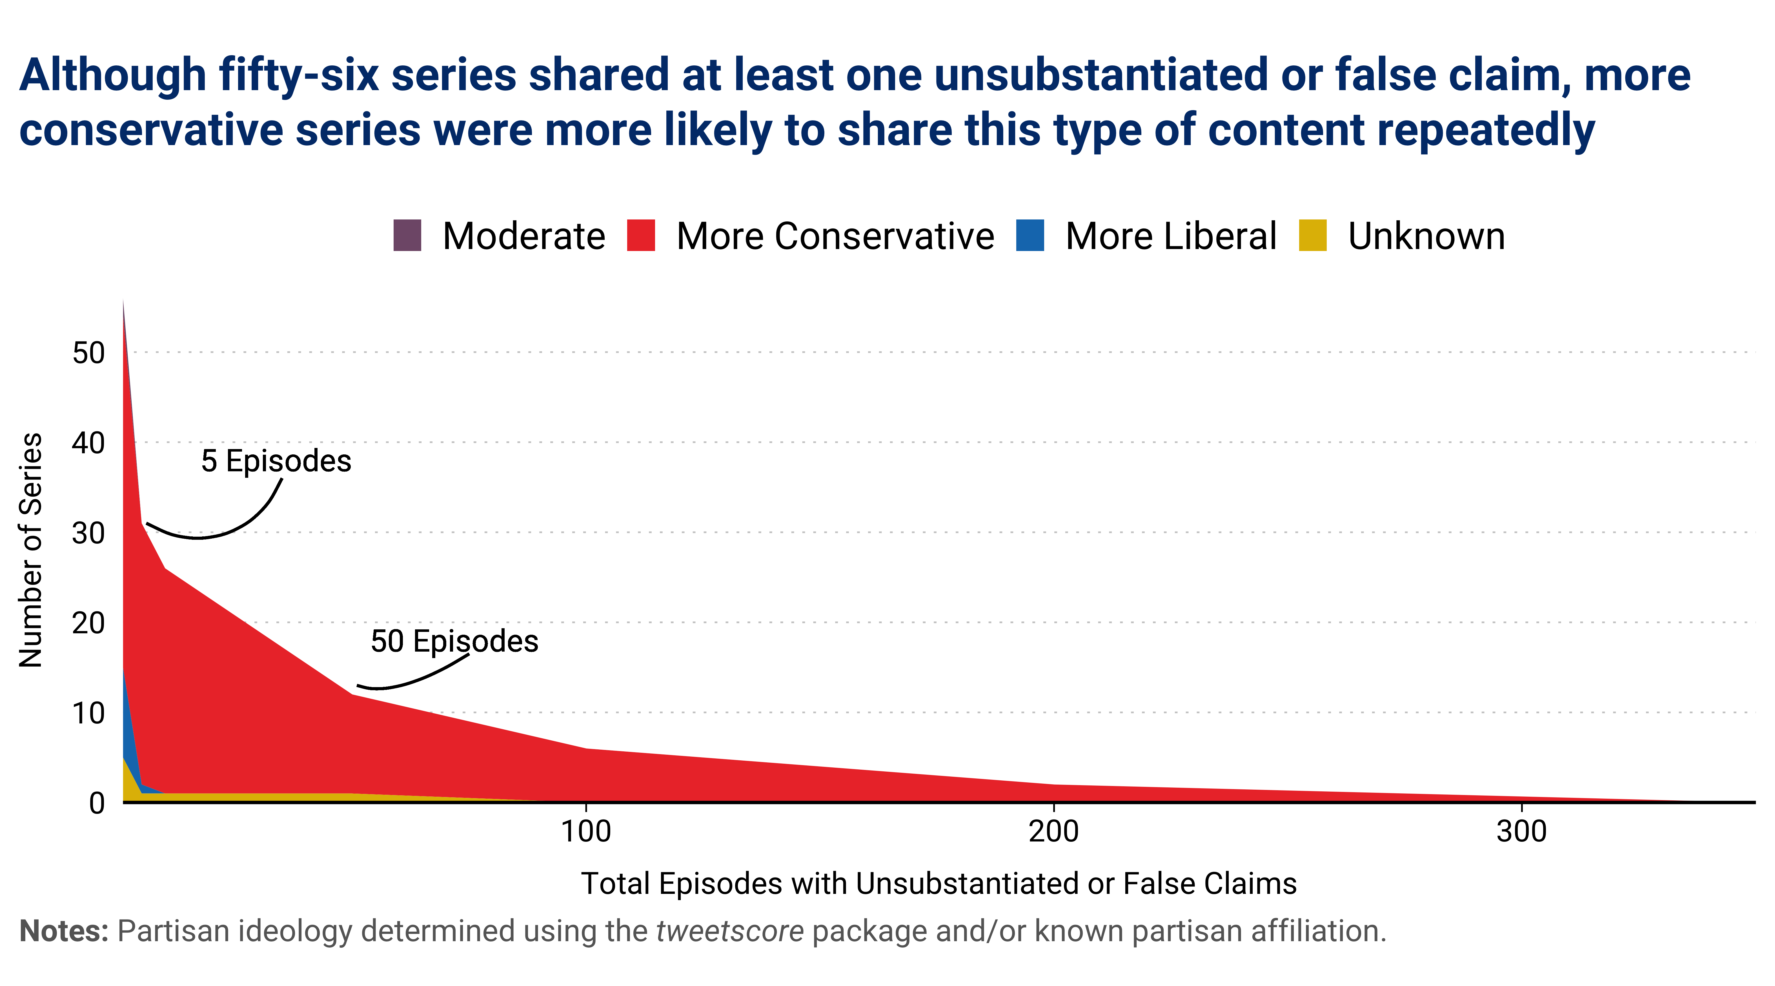

Figure 4 highlights the number of series in the dataset that featured unsubstantiated or false content. I find that 59 of 79 series (71%) shared at least one claim, 31 shared 5 or more claims (40%), 12 shared 50 or more claims (15%) and 2 shared 200 or more claims (2.5%). Beyond 5 or more claims, nearly all of these series are more conservative.

**FIGURE 5**

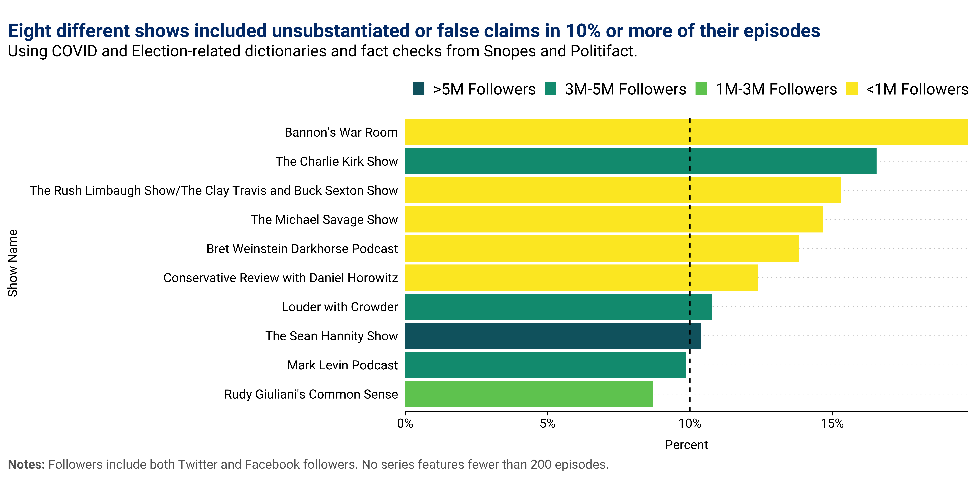

Although several shows included unsubstantiated or false claims in more than 100 episodes, many of these shows produced thousands of episodes throughout the period of analysis. Furthermore, several shows that shared false claims did so at a higher rate, due to a smaller number of total episodes. **Figure 5** plots the shows that shared the most unsubstantiated or false content as a percentage of total episodes. *Bannon’s War Room*, which produced both a high number of episodes and shared the most unsubstantiated or false claims in the dataset tops the list, with close to 20% of all episodes including claims flagged as false by fact checkers or the dictionary of terms. Seven other shows feature false claims in more than 10% of all episodes assessed during this period. Although every show featured claims from each detection strategy, Bret Weinstein | Dark Horse Podcast and Conservative Review with Daniel Horowitz featured primarily COVID-related claims. *The Michael Savage Show* and *The Sean Hannity Show* were more likely than other shows to share claims fact checked as false by external fact checkers. Collectively, these shows reached an audience of more than 28 million followers on Facebook and Twitter, though the reach per show varied significantly, from around 180,000 followers to more than 10 million.

*For fact checked claims, the possible partisan bent of fact checkers does not explain differences in sharing patterns between conservative and liberal hosts*

Specific to the fact checks analyzed, 1,189 fact checked claims appear in podcast episodes, either as the host refuting a claim or endorsing it. These claims cut across the political spectrum: 935 targeted conservative figures and 254 targeted liberal figures. In the podcast episodes, hosts were more likely to refute false claims by liberal figures and share false claims by conservative figures (Figure 6).

**FIGURE 6**

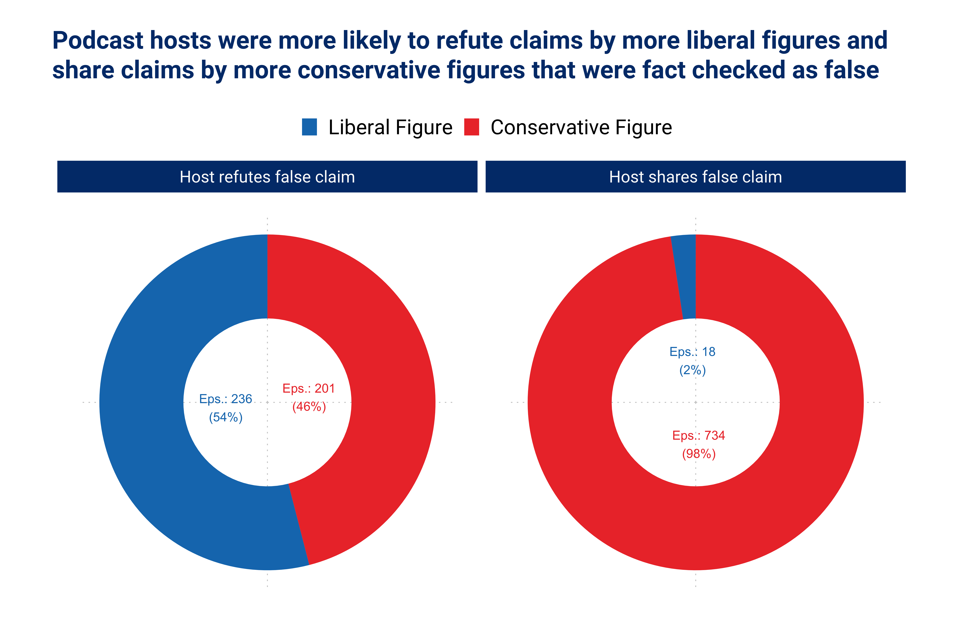

This disparity cannot be attributed to the perceived or real partisan bent of the fact checks.[39] Even though unique fact checks targeting more conservative figures (412) were more than four times as common as unique fact checks targeting more liberal figures (96) in the data, podcasters shared conservative figures' content that was fact checked as false 40.7 times more than podcasters shared false claims made by liberal figures. Accounting for this disparity, podcasters were 10 times more likely to share claims fact-checked as false by conservative figures than liberal figures, with conservative hosts overwhelmingly sharing this content. More conservative podcast hosts were also more likely to refute false claims made by liberal figures, with 20 episodes citing PolitiFact or Snopes directly to bolster their commentary. Across all podcast series, Ben Shapiro, host of the Ben Shapiro Show, was both the most likely to refute a false claim (48 episodes) and the most likely to refute a false claim made by his own party (23 episodes).

The fact checks shared in the dataset focused on a wide range of topics, though elections, non-election politics, health and science, and crime and guns were among the most common for podcasters refuting and sharing false claims (Figure 7).[40] Given that former President Donald Trump’s false or misleading claims totaled over 30,000 during his presidency, podcasts hosts were more likely to both refute and share claims by the former president fact checked as false (Figure 8).[41] Podcasters also commonly refuted false claims made by current President Joe Biden, though they were not among the top 10 most shared.

**FIGURE 7**



**FIGURE 8**



*Users may be able to distinguish between series that share false or unsubstantiated information and those that do not*

Are listeners able to distinguish between series that share false or unsubstantiated information and those that do not? To answer this question, I collect all text reviews from series in my sample and assess both the average score, on a scale of 1 to 5, for Apple reviews, and the average substance of those reviews, on a scale of –1 to 1, with –1 being very negative and 1 being very positive. To calculate the sentiment of the review text, I include both the body and subject of the review and utilize VaderSentiment, a rule and lexicon-based tool for sentiment analysis that is particularly attuned to social media data.[42] The average rating for series in my dataset is overwhelmingly positive: for Apple it is 4.36 and for VADER it is 0.48. These rating measures are also both highly correlated--a show with a higher average VADER score will also have a higher average Apple rating. Yet, what one person rates a 3 on Apple might be another person’s 1, despite similar tenor of their review. As a result, I rely on both measures to assess user engagement with popular podcast series.

**FIGURE 9**

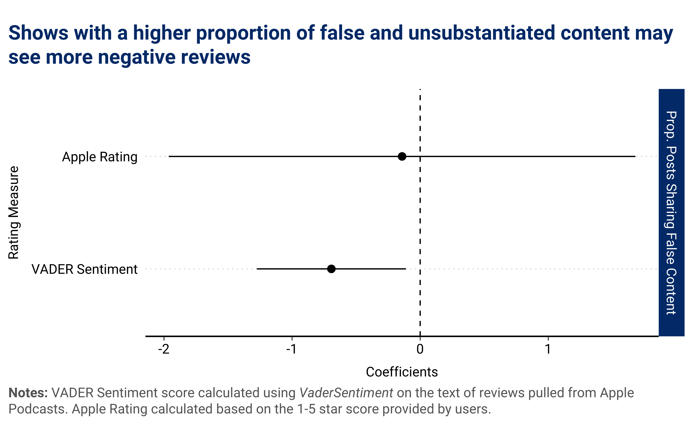

Based on **Figure 9**, the results are mixed. While the VADER method shows a clear relationship between sharing false or unsubstantiated content and more negative reviewer sentiment (i.e., shows with a higher proportion of content sharing false and unsubstantiated claims see more negative reviewer comments), using Apple’s score as a measure of reviewer support is inconclusive. Although many factors could shape the substance of a review, the VADER results suggest that, if platform infrastructure would accommodate it, users may be able to contribute to fostering a higher quality information ecosystem because reviews can at least partially counter or refute false claims.

# 4. Prominent political podcasters played a key role in spreading the 'Big Lie'*[43]*

In an episode that aired on Jan. 6, 2021, titled “For the Republic”, Steve Bannon encouraged his audience to keep faith:...[44]

In hindsight, Bannon’s podcast episode offers a chilling example of the violent rhetoric and blatant disinformation spread by prominent political podcasters after the 2020 election. At this time, podcasters and their guests regularly promoted the lie that the election had been stolen from President Donald Trump, relying on debunked evidence, hearsay, and blatant conspiracies to bolster their claims. Following the attack on the Capitol, social media platforms like YouTube, Facebook and Twitter received scrutiny for their contribution to spreading these narratives.[45] At the time, the role of podcasting barely registered as a concern.

To better understand that role, I evaluated the content of 3,916 of episodes whose shows aired between the first major party convention on Aug. 20, 2020, and the storming of the Capitol on Jan. 6, 2021. I found that:

* One out of every seven episodes endorsed unsubstantiated or false election claims, with the majority coming from series that were among the most popular at the time of the election
  + Among the most popular series, election fraud claims featured in 36% of all episodes, as compared to 5% for shows not in Apple’s Top 100 in November 2020
* After the election, claims of election fraud rose by 700%, from 3% of all episodes (68 of 1,731) in the period from Aug. 20 to Nov. 2 to nearly 30% of all episodes (492 of 2,185) between November 3 and January 6
  + For shows in the top 100 at the time, this number reached over 50% (393 of 778) of all episodes in the period after the election[46]
* Twenty-nine of 79 (37%) different shows shared at least one false or misleading election narrative, with seven shows airing 25 or more episodes with these claims
* Episodes that endorsed false or misleading electoral narratives had broad cross-platform reach, with total audiences on Twitter and Facebook reaching over 100 million

These findings suggest that prior to the Jan. 6 attack political podcasters—and, in particular, the most popular ones at the time--served as a critical and underappreciated vector for the spread of unsubstantiated and false claims tied to the election. With 2020 election deniers running for and winning elected office at high rates, the role of new media, including political podcasting, in framing the contours of these conversations requires additional research and scrutiny.[47]

## The Big Lie in the Mainstream

As Figure 10 reveals, there was a massive post-election increase in podcast episodes that endorsed unsubstantiated allegations of voter fraud and related narratives, with 88% of all claims about election fraud occurring after the 2020 election. Although podcasters occasionally raised concerns about electoral integrity prior to the election, the percentage of all episodes that shared unsubstantiated or false claims about election fraud remained low in the pre-election period. After the election, the number of claims spiked dramatically, with nearly 30% of all episodes in the sample endorsing false or misleading claims. In some weeks, podcasters shared nearly 10 claims per day, or around 70 per week. Amongst shows in Apple’s Top 100 during this period, claims of election fraud featured in over 50% of all episodes.

**FIGURE 10**



What is particularly striking is that the post-election spike in misleading electoral claims also proved to be remarkably durable. After the Electoral College’s “safe harbor” deadline on Dec. 8—when states are supposed to resolve election-related disputes—and countless failed court cases, including a case rejected by the Supreme Court on Dec. 11, we might expect a dramatic decline in fraud-related claims across the podcasting ecosystem.[48] Although the data registers a modest decline around the holidays, in the weeks prior to the Capitol assault, nearly 30% of popular political podcasts episodes--or around 8 episodes per day--endorsed election fraud narratives, despite substantial legal defeats.

The continued spread of election fraud narratives across political podcasting during this period was important for breathing life into these claims, particularly as social media platforms and mainstream media outlets took action to stem their reach. For example, after the safe harbor deadline passed, YouTube launched an effort to remove content that alleged “widespread fraud or errors changed the outcome of the 2020 U.S. Presidential election,” and continued its practice of linking users searching for election-related information to third-party fact checkers and authoritative content.[49] Facebook took preemptive action to stem the reach of political content prior to the election, putting into place what they called “break the glass” measures that restricted the viral spread of political groups where election falsehoods tended to thrive.[50] In the aftermath of the election, Facebook banned a viral “Stop the Steal” campaign group, though some employees and onlookers criticized these measures as too lax and temporary.[51] Twitter also took action by flagging posts from President Trump and others who violated its policies related to election fraud claims or added warning labels and additional context to election-related tweets.[52]

Even conservative mainstream media distanced itself from Trump’s claims that the election had been stolen. Just after the election, some Fox News hosts cut away from election fraud briefings by Trump administration officials, and Rupert Murdoch-owned outlets encouraged Trump to concede.[53] In response to a legal threat from election software company Smartmatic, Fox News also aired a news segment debunking various allegations of election fraud about the 2020 Election from some of its own hosts.[54] Although the restrictions put in place failed to wholly halt the spread of election fraud claims across social and mainstream media, on conservative podcasting, the false allegation that the election had been stolen spread unencumbered and without scrutiny.

As **Figure 11** illustrates, much of the content tied to election fraud was driven by a few shows that both aired a high number of episodes and shared misleading narratives tied to election integrity frequently. Although 29 series shared unsubstantiated or false claims, 10 series shared either 25 or more claims or devoted more than 50% of their post-election episodes to election fraud. Of note is Bannon’s War Room. In keeping with his Trump-era media strategy of “flooding the zone” with inflammatory information (real or fabricated), Bannon not only devoted over 130 episodes to promoting election fraud narratives but also did so on nearly 80% of all episodes recorded during this period.[55]

**FIGURE 11**



These podcasters devoted significant attention toward making election fraud claims seem credible by pointing out the legal consequences of signing a false[56] [affidavits](https://dcs.megaphone.fm/WWO8594473093.mp3?key=1f6804c97668e023a71d497f60c04e34)[57] or highlighted [the](https://podcast9.com/share/episode/P4htqvbOn5W/dave-rubin-on-voting-for-trump-gay-marriage-and-covid-hypocrisy-ep-28) [credentials](https://www.youtube.com/watch?v=Jwj5g-CwOhw)[58] of Trump lawyer Rudy Giuliani (who “took down the mafia in New York City”) and Sidney Powell (who “worked for Michael Flynn”) to signal their credibility. Other podcasters blindly parroted even the most farfetched narratives, including those that claimed Venezuelan leader [Hugo](https://www.youtube.com/watch?v=QKcHeiOpOjk)[59] [Chavez](https://www.iheart.com/podcast/1119-travis-and-sexton-57927691/episode/the-rush-limbaugh-show-podcast--74229834/)[60] had played a role in rigging the election, alleged that rogue [USB](https://podcasts.apple.com/qa/podcast/the-holiday-leftovers-you-cant-ignore-guest-justin-barclay/id620967489?i=1000500504374)[61] cards had added votes to the election tally in Pennsylvania, or blamed the distribution of [sharpies](https://www.youtube.com/watch?v=fiIl8iFoSbw) for Biden’s win in Arizona.   affidavit and highlighting the careers of Trump’s lawyers, including Rudy Giuliani (who “took down the mafia in New York City”) and Sidney Powell (who “worked for Michael Flynn”) as a signal of their prestige.[62] They also regularly shared some of the most implausible election fraud claims, including those that linked deceased Venezuelan leader Hugo Chavez to election fraud and blamed Biden’s victory in Arizona on the distribution of sharpie pens.[63]

Due to the decentralized nature of the medium, and because podcasters often cross-post on other websites or rebroadcast over terrestrial radio, it is difficult to grasp the size of the audience for these episodes. Despite this challenge, other data points can at least provide a glimpse into their possible reach. In March 2022, Steve Bannon’s show, for example, claimed to have been downloaded over 135 million times.[64] Ben Shapiro’s podcast claims to see 15 million downloads per month, and The Verdict with Ted Cruz reportedly had at least 20 million downloads in 2020.[65] In the dataset, hosts that shared unsubstantiated or false content reached a total of 58 million followers on Twitter and 51 million Facebook followers. The average number of followers across Twitter and Facebook for hosts sharing election-fraud related content was nearly 4 million, and the median host enjoyed a reach of 2 million across both platforms. As social media platforms and mainstream media outlets cracked down on election-fraud related claims in late 2020, it is clear based on the data that these narratives found a home amongst a subset of prominent political podcasters.

# 5. How podcasters spread unsubstantiated or false health-related claims during the coronavirus pandemic

Days before the first coronavirus death struck the United States in late-February 2020, podcaster Glenn Beck, founder and CEO of The Blaze, warned his listeners of the virus’s potential impact should it spread: “the coronavirus is going to hammer the global economy if it becomes a pandemic.”[66] But the looming threat of a global pandemic did not register for many podcasters. As coronavirus infections and deaths soared in New York City in April and May 2020, offering a stark warning for the rest of the nation, podcaster Daniel Horowitz--whose podcast promises listeners to “explore the politically right way to think about the issues”--downplayed the severity of the disease: “if you take out New York City, which is unique, how many people is that? You’re talking about getting struck by lightning, you’re talking about risk levels that are not elevated above any other activity associated with your daily lives.” And John Solomon, a former Fox News contributor and executive and editor-in-chief at The Washington Times, argued that coronavirus “does exactly what all other respiratory disease epidemics during the flu season do: they come for two weeks, they stay at the peak, they go, and it's over.”[67]

No other issue has illustrated both the devastating consequences of—and challenges with classifying—unsubstantiated or false claims more so than the coronavirus pandemic. These consequences are numerous and well-documented.[68] According to the Department of Health and Human Services, the “infodemic” of unsubstantiated and false content tied to the pandemic “has led people to decline vaccines, reject public health measures, and use unproven treatments. Health misinformation has also led to harassment and violence against health workers, airline staff, and other frontline workers tasked with communicating evolving public health measures.”[69]

As a result, understanding how and why these claims spread across popular information platforms is of vital importance. Since the pandemic began, social media companies like Meta, Twitter, and Google have taken a leading role in framing the contours of conversation, with mixed success.[70] The role of podcasting remains absent from these discussions, despite some referring to it as the “Wild West” for unsubstantiated or false claims related to COVID due to the medium’s unregulated nature.[71] Yet apart from public backlash against podcast host Joe Rogan for promoting unproven COVID-19 treatments, the spread of unsubstantiated or false claims tied to the pandemic in popular political podcasting has not received significant attention.[72]

To understand the role of podcasters during the first two years of the pandemic, I evaluated the content of more than five thousand episodes beginning in January 2020, when the first cases of coronavirus were reported in Washington state. I found that:

* Unsubstantiated or false claims tied to COVID were fairly common, reaching one out of every eight episodes examined during this period.
* These claims primarily focused on unproven, alternative treatments and preventions, with more than 3 times as many episodes promoting these claims as the next most common category tied to vaccine efficacy and side effects.
* The shift of pandemic response responsibilities from Republican President Donald Trump to Democratic President Joe Biden did not visibly alter the spread of unsubstantiated or false claims tied to coronavirus
* Spikes in unsubstantiated or false coronavirus-related claims can be clearly tied to specific events through the pandemic. For example, the single most consequential event for content tied to alternative treatments and prevention was a press conference held by America’s Frontline Doctors touting the benefits of hydroxychloroquine in front of the Supreme Court Building in July 2020.
* Fringe conspiracy theories, like vaccines containing a microchip, were for the most part absent from coronavirus discussions amongst popular political podcasters. Instead, unsubstantiated or false claims were far more nuanced and rooted in misunderstandings of science and a heavy reliance on non-peer reviewed preprints.

## The Trajectory of Unsubstantiated and False Claims during the COVID-19 Pandemic

Throughout the pandemic, unsubstantiated or false health-related claims remained a constant challenge hindering the public health response.[73] In tandem with the evolving nature of the pandemic, a widespread “infodemic“ made it far more difficult for public health officials to share important information with the public, often due to the viral spread of contradictory--and often false--claims tied to the coronavirus response. The viral spread of unsubstantiated claims had the effect of “diluting the pool of legitimate information” and “undermin[ing] trust in health institutions and programmes” in service of “the comfort of an explanation in times of uncertainty and anxiety.”[74]

Podcasters played a clear role in perpetuating this infodemic. In total, I find that these claims made up a healthy percentage of the podcast episodes – about one in every eight episodes I assessed contained claims that were not backed by scientific consensus. Thirteen series in the dataset shared 10 or more unproven claims tied to the pandemic, reaching nearly 40 million across Twitter and Facebook.

As Figure 12 demonstrates, by far the most common focus of these claims stemmed from the promotion of alternative treatments and prevention. Amongst these claims are the beliefs that hydroxychloroquine and ivermectin — an anti-malaria drug and anti-parasitic drug, respectively – could treat or prevent COVID-19 altogether. In the early days of the pandemic, Trump and other public figures speculated about the efficacy of hydroxychloroquine, and the FDA listed the drug as a potential treatment and prophylaxis among hospitalized COVID-19 patients.[75]Following reports of cardiac adverse events in COVID-19 patients receiving hydroxychloroquine treatments, the FDA issued caution against using the drug outside of a hospital or clinical trial setting. The president, however, continued to tout its purported efficacy. By June 2020, the FDA had already revoked hydroxychloroquine’s emergency use authorization (EUA).[76] The Trump administration reacted to the move by calling it a “Deep State blindside by bureaucrats” and continued to push the medication into the summer 2020, even as many public health officials deemed it ineffective.[77] In podcast data, claims about the efficacy of hydroxychloroquine--which I only began tracking after the FDA revoked its EUA--skyrocketed in the summer of 2020 and remained a constant feature throughout the period of analysis.

**FIGURE 12**

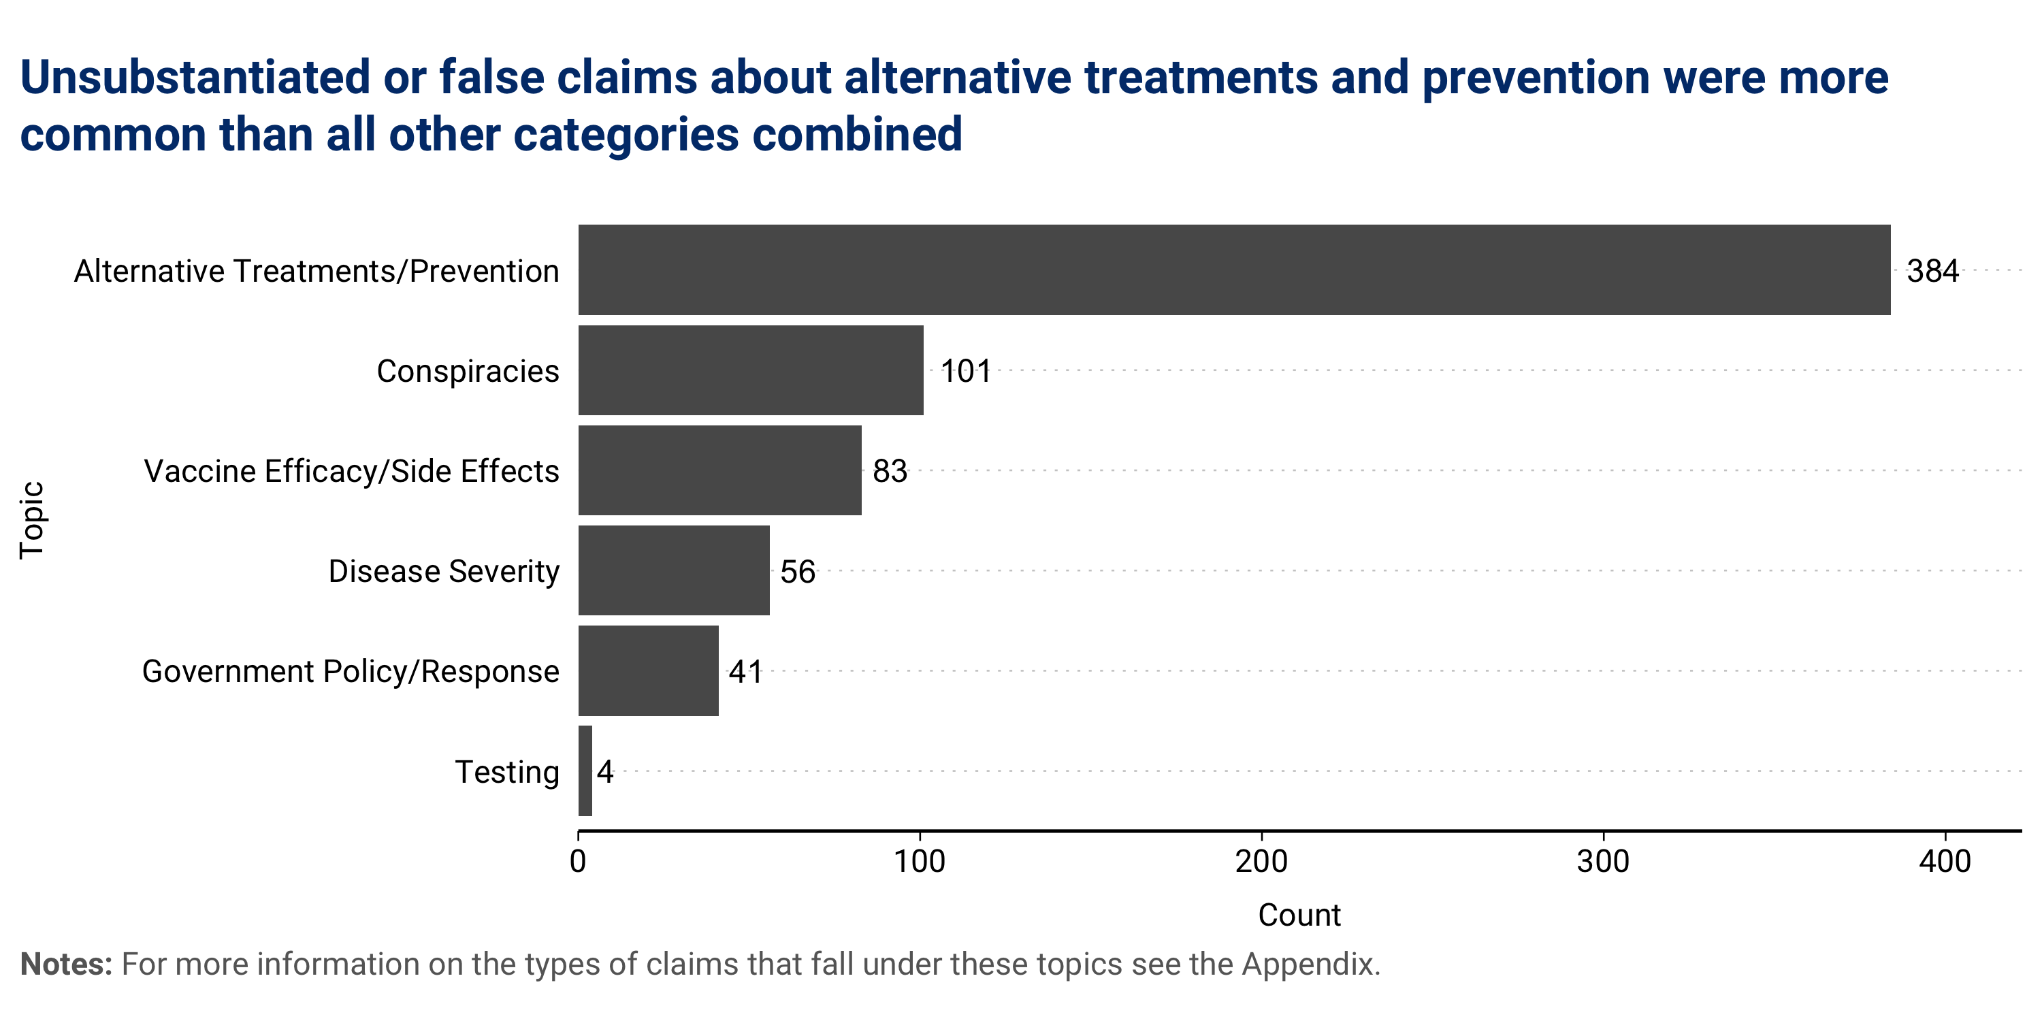

The use of ivermectin as a potential treatment or prophylactic for COVID-19 emerged more organically than hydroxychloroquine, as part of a punditry-led process instead of government-driven politicization. The first reference of ivermectin in the dataset can be traced to August 2020, a guest on Charlie Kirk’s podcast included it among a list of drugs that “should also be available to doctors.”[78] In early September 2021, podcast host Joe Rogan revealed that he tested positive for COVID-19 and had been taking ivermectin to mitigate some of the virus’s worst symptoms.[79] Despite CDC warning that ivermectin was “not authorized or approved by FDA for prevention or treatment of COVID-19,” the drug quickly gained mainstream attention, though it had been circulating in political podcasting since early 2021.[80]

Importantly, an election that saw the pandemic response change hands from the presidency of Donald Trump to the presidency of Joe Biden played little role in shaping the trajectory of the coronavirus infodemic, with a high number of unsubstantiated and false claims spread both before and after the election. I plot the course of these claims over time in **Figure 13**. Although unsubstantiated and false claims tied to the pandemic became a more regular feature during the presidency of Joe Biden, this also coincided with the vaccine rollout, which offered a new focus for these claims not previously available to podcasters during Trump’s presidency.

**FIGURE 13**

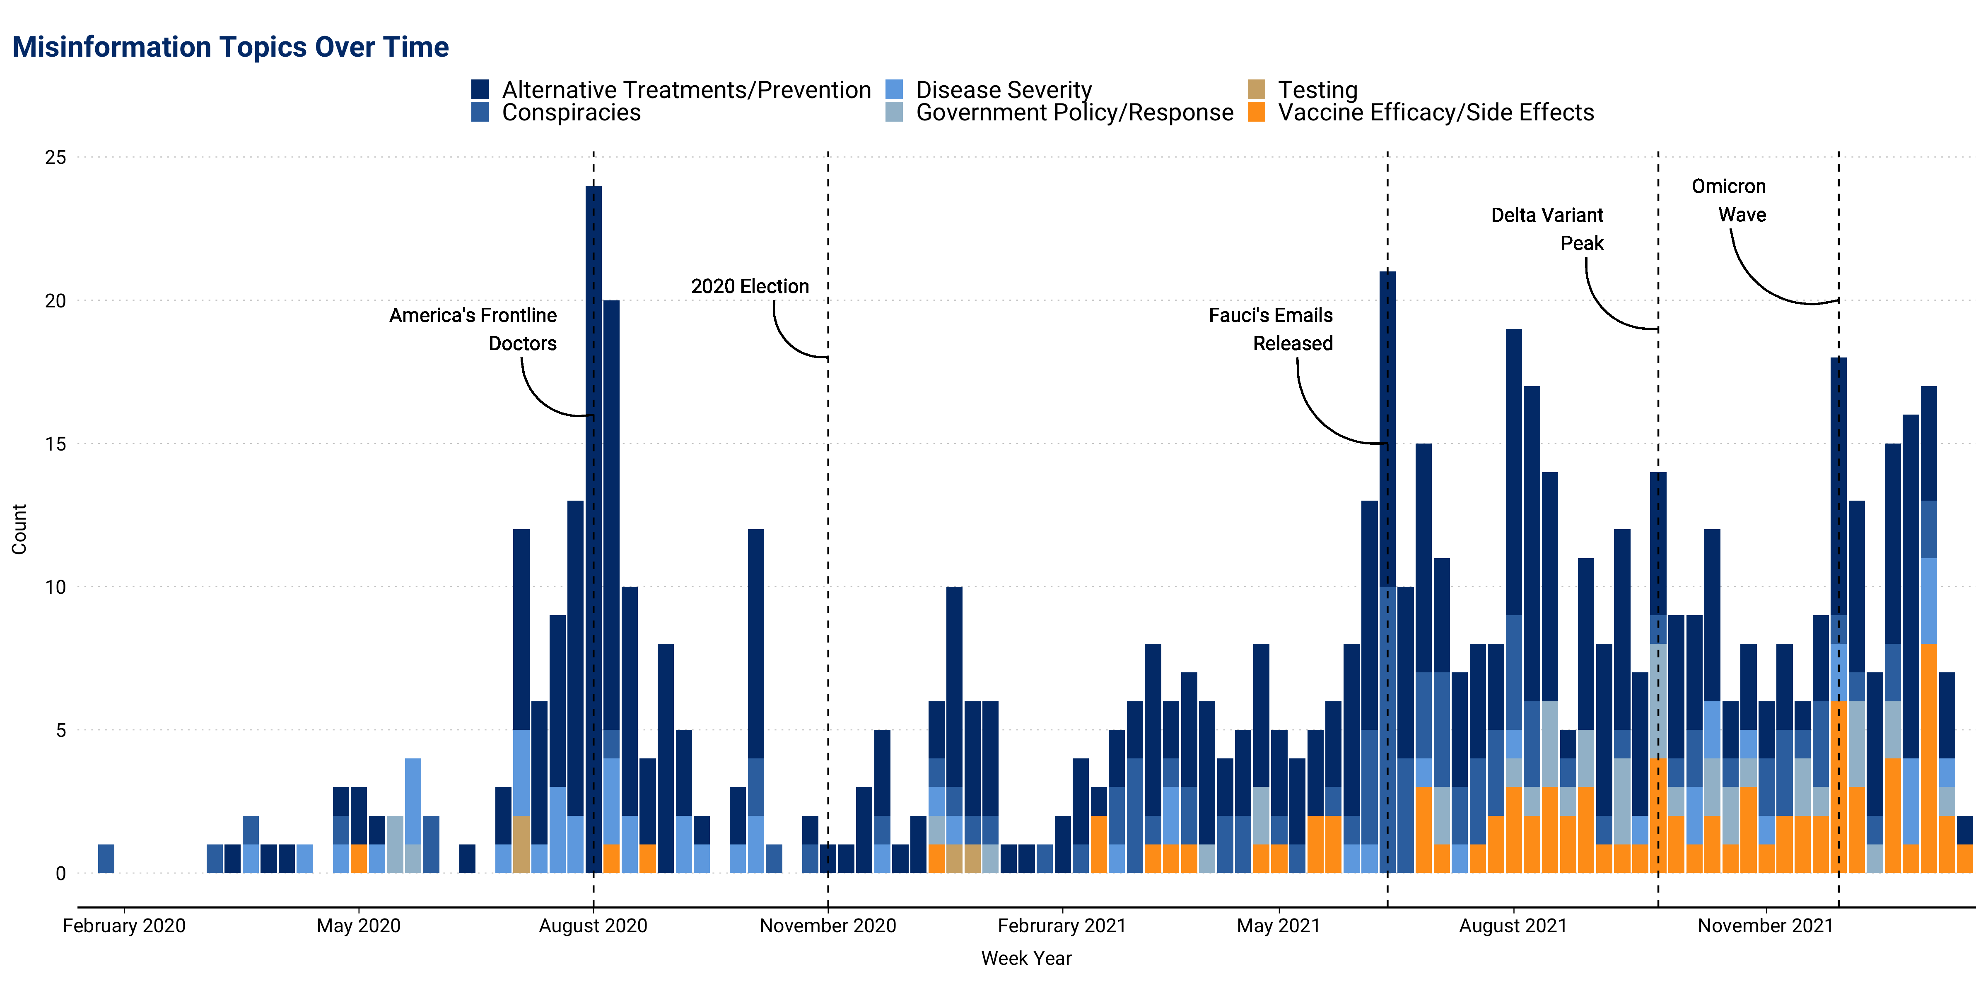

Instead of the election, key moments and events in the evolution of the pandemic seem to drive surges in this type of content. For example, the single most consequential event tied to alternative treatment claims was a press conference held outside the Supreme Court Building by America’s Front-Line Doctors in late-July 2020. There, Dr. Stella Immanuel proclaimed, “America, there is a cure for COVID. All this foolishness does not need to happen. There is a cure for COVID. There is a cure for COVID is called hydroxychloroquine. It’s called zinc. It’s called Zithromax.”[81] The video was quickly picked up across social media, which led platforms to crack down on its distribution, prompting backlash against perceived censorship and spurring broader distribution, including across the podcasting ecosystem. Within two weeks after Immanuel’s press conference, 42 podcast episodes shared claims about hydroxychloroquine’s efficacy, or around three claims per day. In these episodes, podcasters, like Mark Levin, quoted from her press conference at length, highlighting support of hydroxychloroquine from “professors from the finest institutions” and “exquisitely educated and experienced doctors from the finest hospitals.”[82]

Similarly, the release of Dr. Fauci’s emails on June 2, 2021, via a Freedom of Information Act request marked the single most consequential event for conspiracy-related content. His emails included exchanges with domestic and foreign government and health officials, the media, and everyday Americans regarding daily briefings and, notably, speculations of the virus’ lab origin and mask efficacy during the early stages of the pandemic. Following their release, podcasters, like Steve Bannon, seized the opportunity to push theories that Fauci knew early on that this was a “genetically engineered bioweapon” and “decide[d] not to tell the president” and that Fauci and others “stood to profit if this turned into a pandemic.”[83]

Following the widespread rollout of the vaccine in early 2021, vaccine-related claims remained steady over time, with a slight spike registering as vaccine-induced immunity began to wane during the height of the Omicron wave in early 2022, necessitating the need for booster shots. During this period, podcasters questioned the efficacy of vaccines, highlighting research that seemed to claim that “death after the vaccine at any age group is more likely than actually taking your chances with COVID-19" and that “what we really have is a poison death shot, it’s not a vaccine.”[84]

## Science in the Face of Uncertainty

Among prominent political podcasters, I found relatively little promotion of fringe theories and ideas. For example, not one podcaster in the dataset endorsed claims about microchips in vaccines or injecting bleach as a COVID repellent, among other more far-fetched claims commonly discussed on social media and in the news. The most frequent conspiracy shared was the claim that COVID-19 resulted from a Chinese Communist Party led plot to stop Donald Trump’s reelection. As Figure 14 shows, Bannon’s podcast alone accounted for more than 1/4 of all COVID-related claims and nearly ¾ of all conspiratorial content on political podcasts. In one episode, Steve Bannon lauded efforts to reveal “the truth about the coronavirus being made and re-engineered by the CCP and intentionally released to the whole world as part of their evil plan.”[85] In another he added, “I was looking at the classified information...and I'm thinking is this a bioweapon that they're gonna take President Trump down with?”[86]

**FIGURE 14**

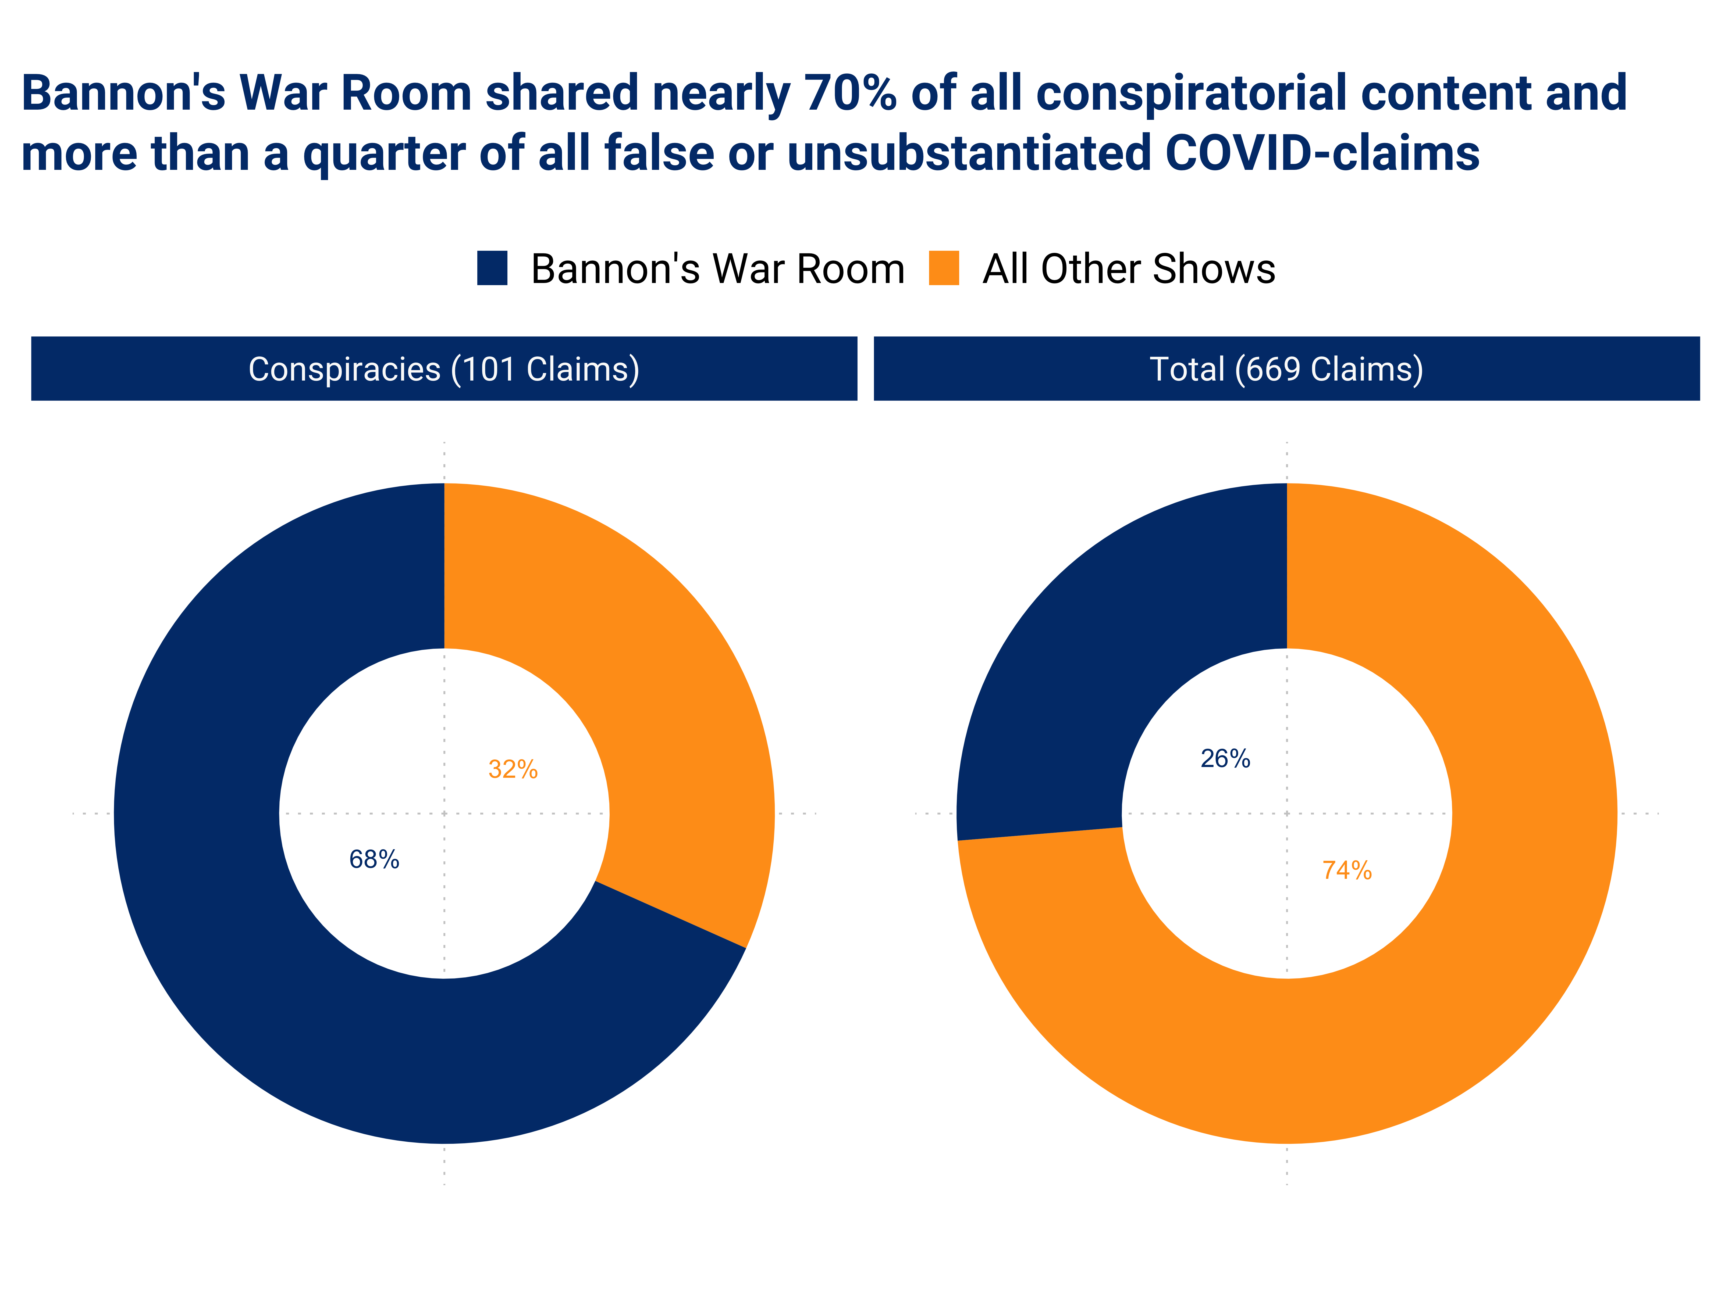

Yet outside of these conspiracies, unsubstantiated or false claims shared during this period were far more nuanced, and primarily built around a misunderstanding of science. In this space, several prominent podcasters were able to carve out positions of authority during a period of high uncertainty. For example, Heather Heying and Bret Weinstein relied on their evolutionary biology background to amass a wide audience for their unconventional coronavirus advice. The pair regularly repeated unproven claims about the prophylactic use of various treatments, including ivermectin and hydroxychloroquine, and cast doubt vaccine safety and its ability to cause mutations.

Throughout their episodes, Heying and Weinstein attempted to bolster perceptions of their credentials by using technical terms. In one episode, Weinstein offers a “little brain teaser” that “correlation is in fact evidence of causation if there was a causal hypothesis pre-existing the observation of the correlation.”[87] As he speaks, Heying nods affirmatively and then proceeds to reiterate this claim. While it’s unclear exactly what they are referencing, perhaps the most basic tenant of statistics emphasizes that correlation does not equal causation and is instead susceptible to confounding. For example, some podcasters highlighted a theory that COVID-19 was less common in African countries because people took hydroxychloroquine for malaria.[88] While this could indicate a clear link between hydroxychloroquine and the prevention of COVID-19, there are many alternative explanations, including the inflow and outflow of people. Although researchers can control for potential known confounders, there may be infinitely more unknown ones driving any observed relationship. Rather than protecting researchers against confounding, a pre-existing hypothesis may instead make them more susceptible to confirmation bias. Deploying this language, however, may be designed to bolster the scientific bona fides of the hosts in the presence of a non-technical audience. These efforts, which were a common feature in many episodes, certainly bore fruit. Weinstein’s reach on Twitter grew from around 278 thousand in May 2020 to over 732 thousand in September 2022, with weekly follower gains accelerating rapidly in the early days of the pandemic[89] Heying’s reach also accelerated in parallel, with around 86 thousand followers in May 2020 to more than 200 thousand as of September 2022[90][91]

Some podcasters also cited non-peer-reviewed preprints and data, often with faulty statistical analysis or poor research designs, to bolster their prior beliefs (e.g., about the efficacy of ivermectin) while summarily dismissing similar non-peer-reviewed studies whose conclusions ran contrary to their preferences (e.g., about the spread of COVID as a result of the Sturgis Bike Rally).[92] Podcasters even cited “medRxiv” as a publisher, even though this website is not a journal but rather a broadly available, free repository of preprinted manuscripts with limited vetting procedures.[93] The website also explicitly states: “Preprints...should not be relied on to guide clinical practice or health-related behavior and should not be reported in news media as established information.”[94]

The reliance on preprints as evidence by non-technical audiences is one of the most pervasive trends of the coronavirus pandemic. Recent research has found a huge spike in the sharing of preprinted journal articles in the early stages of the pandemic, with the largest increase in preprint shares on social media coming from conservative users.[95] These preprinted studies have also formed the basis of faulty policy, such as the dispersal of ivermectin in medical kits in Mexico.[96] Although preprints play a vital role in disseminating research to audiences during what may normally be a lengthy peer review process, in times of scientific and medical uncertainty, they may play a detrimental role in shaping public opinion amongst audiences who may lack the credentials to critically evaluate each study for its technical merits.

Podcasters also often expressed frustration with the mixed and shifting messages from policymakers and public health officials. Attempts by policymakers to reassure an anxious public during a time of uncertainty by projecting a high degree of false certainty were often met with backlash later, as the trajectory of the pandemic evolved.[97] For example, in an interview with 60 Minutes on March 8, 2020, Dr. Anthony Fauci attempted to reassure the public about the severity of the emerging virus by stating “there’s no reason to be walking around with a mask.”[98] This interview predated the CDC’s updated recommendation on April 3, which mandated face coverings and masks in public settings due to an evolving understanding of the science behind the virus. But later in the year, Fauci’s early remarks began to reappear across podcasts and on social media, as political commentators questioned the necessity of widespread masking.[99] More broadly, these shifting recommendations based on evolving science led some podcasters to question the nature of scientific inquiry altogether. Sarah Gonzales, who has a “background in microbiology and chemistry,” criticized the evolving science around hydroxychloroquine: “so the science changed. I thought science doesn’t[100]

More broadly, classifying content as “false or misleading” during a pandemic – particularly when uncertainty is exceptionally high – proved to be a complicated and occasionally counterproductive exercise. What might have been considered true at one point (e.g., the Pfizer vaccine is 95% effective at preventing infection), might be less accurate down the road, as knowledge accumulates, or new variants emerge.[101] Yet the consequences of missing the mark or changing guidelines as the trajectory of the pandemic shifts may be even more consequential, leading to an erosion of trust or total rejection of scientific consensus.[102] This was the case following a crackdown against the so-called “lab leak” theory in February 2020, which hypothesized that the coronavirus had been man-made or manufactured and accidentally escaped from the Wuhan Institute of Virology. Facebook removed content endorsing the lab leak theory and even permanently banned some users for perpetuating it.[103] When further research failed to wholly rule out the lab-based origins of the virus, the social media platform backtracked on its previous ban. This incident may have done damage to Facebook’s ability to prevent the spread of other types of claims that ran contrary to scientific consensus by leading some users to believe that the platform operated with a partisan agenda[104]

As researchers at Data & Society note, framing debates over ongoing scientific inquiry, such as hydroxychloroquine usage for coronavirus treatment, “as a battle between legitimate scientific information vs. dangerous misinformation” overlooks more nuanced discussions about the role of evidence in medical decision making and the amount required for medical professionals to make a recommendation in accordance with their oath to "do no harm.”[105] This suggests lessons for fact checkers and social media companies working to create a safe information ecosystem in the face of an unprecedented flow of potentially deadly information, while simultaneously guarding against absolute policies in a highly fluid external environment.

# 6. Policy Recommendations for the Podcasting Medium[106]

In the aftermath of a once-in-a-generation pandemic and violence following the 2020 elections, social media companies have grappled with how best to balance the necessities of content moderation with the importance of free expression. Although these experiences provide useful lessons, the spread of false and unsubstantiated claims, rumors, and other misleading content in podcasting poses a unique challenge due to the medium’s decentralized nature. Unlike social media platforms, which directly host content generated by users, podcasts are hosted across a wide range of websites. Most podcasting apps do not host that content. Instead, in the words of podcast commentator Nick Quah, they act more as “the impartial steward (and enforcer) of the open podcast ecosystem.”[107] As a result, it is unclear where responsibility for the content shared via podcasts lies. Due to the diffusion of responsibilities inherent to the podcasting ecosystem, improvements to the space will require the input of a range of actors, from tech companies to podcasters, who all play a role in shaping the quality of conversations across the medium.

## The Role of Podcasting Apps and Tech Companies

Since the early years of the medium, podcasting apps have taken a hands-off approach to moderating content and provided a relatively sparse architecture to facilitate the distribution of podcast episodes. As the medium continues to evolve and expand, the tech companies that develop podcasting apps can play an important role in shaping the information ecosystem by developing more robust content moderation guidelines and practices, promoting greater transparency, and improving in-app experiences for users.

*Content Moderation*

The tech companies that develop podcasting apps have until recently avoided wading into content moderation debates across the podcasting ecosystem. Despite being the primary link between content creator and audience, these apps do not directly host the content themselves. Instead, they act more like search engines. However, rather than cataloging content across the web, they organize available content across a diverse network of RSS feeds unique to each podcast series. Podcasting apps have compared themselves to search engines to avoid a more active role in the ecosystem, but many popular search engines have also established guidelines for the content they will return in their search results[108][109]

As the medium grows in popularity, podcasting apps will be forced to reckon with how they handle content that falls into the so-called “lawful but awful” domain, such as hate speech, misinformation, and targeted harassment. These policies will have to balance a desire to limit the real-world harm that can stem from the mass dissemination of harmful content, with a vital necessity not to curtail speech too aggressively or inconsistently. To address these challenges, the tech companies that develop podcasting apps should:

* **Provide more detailed and transparent guidelines for the content that podcasters can share on their apps.** At present, podcasting apps take a passive approach to content moderation, with minimal guidelines detailing what they will and will not share with listeners. Apple’s guidelines, for example, prohibit “defamatory, discriminatory, or mean-spirited" content, but provide little explanation for how these terms are defined.[110] Clearly delineated guidelines that are consistently enforced will help podcasting apps make content moderation decisions in a more systematic manner. In addition, clearer guidelines will help podcasters understand what kinds of content may lead to episode removal across these platforms. In tandem with more transparent content moderation guidelines, podcast apps should provide a means for hosts to contest decisions made based on these guidelines.
* **Provide more detailed and transparent guidelines for the content that apps will promote or recommend.** In addition to guidelines detailing what tech companies will host, many platforms have developed separate guidelines for detailing the types of content their recommendation algorithms will promote.[111] Outside of word-of-mouth recommendations, users often discover new podcasts through in-app recommendation systems, like a “most popular” feature or a personalized recommendation.[112] Podcasting apps like Spotify and Apple podcasts should develop similarly detailed policies around the types of content they will play on their app but will and will not amplify to their user base via recommender systems.[113]

*App Architecture*

Despite the growing influence of the medium, the architecture that underpins podcasting apps has not evolved significantly. As the podcasting ecosystem continues to grow, tech companies could consider updates to their podcasting architecture. Changes to the app ecosystem will not only create a better information environment across the industry, but also open new pathways for drawing audiences to the medium by improving user experiences and fostering greater in-app engagement. The tech companies that develop podcasting apps should:

* **Improve reporting processes across podcasting episodes.** At present, podcast apps have not developed sophisticated, real-time systems to identify harmful content at scale. Absent more robust investment in data-driven algorithms or in-house moderation teams, these apps must rely on user reports to identify content that should potentially be removed. Yet these systems are poorly designed, sometimes difficult to find, or altogether lacking across major podcasting apps. For example, Apple allows user reports focused on just four categories: “Concern with a Show or Episode,” “Broken Feature”, “Feature Request” or “Other.” These vague criteria do not highlight specific “concerns” and fail to distinguish between issues with an entire series or a specific episode. In Google’s Podcast App, users can simply “send feedback” via their Gmail account. To improve reporting processes across podcasting apps and leverage the “wisdom of the crowd,” podcast apps should provide reporting features with: (1) clear in-app icons that guide users through the reporting process; and (2) categories for different violations in accordance with content moderation guidelines.
* **Develop an app architecture that allows for richer community engagement and a more dynamic information environment.** To improve the quality of the information ecosystem and strengthen app engagement, podcasting apps could experiment with a variety of in-app features, including voting and commenting systems and additional features at the episode level. With the development of open-source transcription models, like OpenAI’s Whisper, adding transcripts to episodes has never been easier. Building on ad hoc, decentralized contributions from fans, users and hosts could also add show notes and references to podcast episodes.[114] And podcasting apps could experiment with upvoting and downvoting for these contributions, drawing inspiration from community-driven websites like and [Stack Overflow](https://stackoverflow.com/help/privileges/vote-up), as well as other open forums like [Discourse](https://meta.discourse.org/t/discourse-voting/40121?u=joebuhlig), allow users to both upvote and downvote content and leave comments on posted content. The goal of this approach is to leverage the collective knowledge of the community to ensure that quality content is featured prominently across these platforms. “Wisdom of the crowd” approaches such as these aren’t feasible for every app, and they need to be developed in a way that guards against adversarial or other attempts to [game the system](https://gizmodo.com/reddit-is-tearing-itself-apart-1789406294). Yet they could incorporate a variety of different types of features to enrich the information environment, including transcripts, show notes or references. These efforts could build on ad hoc contributions from fans, often posted to external websites, and consolidate them for a more enriching in-app experience.[115] Beyond a more highly developed podcasting experience, improvements to the app architecture that allow for this level of engagement offer a promising way to transform the podcasting ecosystem from a monologue – where the host speaks and information is passively consumed by the audience -- to more of a conversation among listeners, thereby helping to fuel dialogue and debate amongst listeners (and perhaps, creators too).Reddit and Stack Overflow.[116] Although these approaches would need to guard against efforts to game the system, they could help to build a more information-rich, in-app experience for users.[117] This effort could also help to solve one of podcasting’s core challenges by transforming the ecosystem from a monologue, driven by the host exclusively speaking to the audience, into more of a conversation amongst listeners (and, perhaps, creators too).

## The Role of Policymakers

Government officials, including regulators and policymakers, also have a role to play in improving the podcast ecosystem. Doing so, however, requires that they strike a delicate balance between maintaining rights to freedom of expression and well-documented harms like harassment and discrimination. To accomplish this, policymakers and regulators should neither seek to prohibit legal speech nor put pressure on podcast apps to ban content with which they disagree. However, they can play a vital role in pushing for greater transparency across the podcasting ecosystem. While it may be prohibitively cumbersome to press for oversight across the entire medium, for applications and series with wide-reaching appeal, policymakers should encourage greater transparency on:

* **Content guidelines and policies.** Regulators should require apps to clearly delineate their content moderation policies, with appropriate examples or clarifications for vague wording like “mean-spirited.” Without clearly defined, transparent guidelines, content moderation made by podcasting apps will appear ad hoc and undermine the trust of users.
* **Moderation practices and appeals process.** Regulators should also require podcasting apps to provide high-level, public disclosures about content moderation practices. Policymakers should also require that apps publish clear guidelines on how to dispute content moderation decisions (such as episode or series bans) and provide appellants with a transparent appeals process.
* **Recommendation algorithms.** Policymakers should require podcasting apps to provide high-level details about their recommendation algorithms and the process by which certain content is amplified over others. This is particularly important given the role that these algorithms play in the discovery of new series by listeners.
* **Podcaster funding**. Despite the importance of advertisement and sponsorship revenue to the podcasting ecosystem, at present there are no obvious requirements for financial disclosures beyond those agreed upon between the series and its sponsors Although popular podcasting apps require advertisements to comply with “applicable laws,” it is unclear how apps determine if and when there is a violation. As a result, anyone could fund a podcast with a wide and influential reach, and no disclosure of this financial relationship would be required. Much like financial disclosures in the radio industry, regulators could help shed light on the nature of these financial relationships—and their opaque business models—by requiring podcasters to report major streams of funding for their series.[118] Due to the size of the ecosystem, these requirements might only be applied toward shows that generate a certain amount of revenue or who have an audience above a certain threshold.

## The Role of Users and Podcasters

Alongside tech companies and policymakers, users and podcasters also play a vital role in shaping the podcasting ecosystem. Although apps may build out new features to improve their infrastructure, making changes such as improving reporting processes, incorporating external links, building out transcript repositories, or detailing podcast episode guests require a user base willing to contribute to the conversation. For popular shows with highly engaged fanbases, like the Joe Rogan Experience, this would likely be of little concern. However, less popular shows may draw fewer fan contributions, making the podcaster a critical partner in these efforts. To this end, podcasters could provide transcriptions, highlight key episode topics and themes, or link to external references, for example. Apps could then reward creators for their efforts toward creating a richer information ecosystem by potentially boosting their content.

Additionally, podcasters – who are often attributed a certain level of esteem by their audiences – should recognize their position of authority and use it wisely. As a result of that authority, it is critical that podcast hosts qualify their statements with the appropriate level of uncertainty, challenge guests who fail to do the same, and bolster seemingly factual statements with evidence, perhaps by sharing relevant links. An example of this dynamic was on display most recently during an episode of the Joe Rogan Experience, when Rogan was fact-checked in real time, both by a guest and later by external sourcing.[119]

Specifically for unsubstantiated and false health-related claims, it is critical for podcasters – and all media figures -- to recognize the limitations of their expertise, and refrain from sharing research and resources that have not gone through a rigorous peer review process, unless they wholly understand the methods and statistical processes (along with their shortcomings and assumptions) used in these papers. This is not a phenomenon unique to one end of the partisan spectrum. Nor is it unique to podcasting. Yet, sharing preprints prior to rigorous peer review may pose significant costs to the public health response and may even lead people to make decisions that could risk their lives or cause a level of hysteria not backed by scientific consensus.

## 6.1 The Future of Podcasting

Podcasting as an information medium is only now beginning to play a vital role in shaping public opinion and political debates. As the industry evolves, it could shift in a variety of different ways, all of which have implications for the roles and responsibilities of tech companies, regulators, users, and hosts. Signs of this transformation are already evident, as more platforms seek to capitalize on the unexpected success of the medium.

The Spotify-model of exclusive content relationships built around a single, larger platform represents one such avenue for expansion. In this model, podcast apps have in many ways transformed from distributors to both distributors and publishers.[120] As podcasting becomes an even more popular medium, it is possible that the industry could shift further in the direction of the Spotify-model. In many ways, this would make content moderation challenges more straightforward by eliminating issues with information diffusion across numerous platforms and consolidating responsibility for content creation within the hands of a single (or few) publisher. YouTube, for example, has signaled their interest in this space by both hiring an executive to lead its podcasting efforts and reportedly offering podcasters as much as $300,000 to record video of their episodes.[121]

Other platforms are also expanding into the medium with a more subscription-based model that allows for exclusive content to be shared with subscribers, often for a small fee. Substack, a digital newsletter platform, has also recently entered the podcasting conversation as a rival to Patreon, a platform that allows creators to provide subscribers with additional paywalled content.[122] In both cases, putting exclusive content behind a paywall will make monitoring the medium more difficult, but it may also restrict the unfettered reach (and potential accidental discovery) of “lawful but awful” content to only those who are willing to pay directly for it.

Despite these clear shifts designed to bring more revenue to podcasting, it is still unlikely that the largely decentralized nature of the medium – as embodied by the RSS feed architecture -- will disappear entirely. What is more likely is that as decentralized content creation expands, so will podcasting’s role in this broader digital information ecosystem.[123]  This openness will likely remain a central, if not defining, feature of the medium, exacerbating the challenges detailed throughout this report.

Given these diverging paths for the podcasting industry, it is even more critical to develop adaptable, overarching strategies for improving the podcasting ecosystem. These strategies tap into and build on existing policy debates around content moderation and algorithmic transparency, but also recognize the unique – and evolving – nature of the medium. Although the medium may change in a variety of different ways over the next few years, it is clear that podcast apps, users, and regulators all have a role to play in shaping the quality and contours of this increasingly important information environment.

**Acknowledgements**

I would like to thank Chris Meserole, Jessica Brandt, Elias Groll, and Derek Belle for their invaluable support of this project, and Melody Chen, Adya Danaditya, Dylan Hanson, and Isabelle Sharon for their excellent research assistance. Thanks also to Aaron Rudkin for the initial spark to kickstart the data collection process vital this project and Chad Hazlett for technical guidance. All errors are my own. XXXX and XXXX

# Appendix 1: What is an RSS feed?

Developed in 1999 by Netscape, RSS stands for “Really Simple Syndication.”[124] Written in the web language XML, which incorporates information between so-called “tags” like <title>, the RSS feed provides an RSS reader with instructions for what content resides on the feed and how to read it. The reader, which plugs into a series’ content via a URL, is then automatically updated as new episodes are added to the feed. If data is removed from an RSS feed, it is no longer available through an RSS reader. While RSS feeds used to be more commonly used for news headlines and blogs, they are now largely linked to the podcasting space, despite efforts to move away from the RSS architecture, which some executives in the space view as “outdated technology.”[125] An example of a raw RSS file tied to the popular podcast “The Ben Shapiro Show” is included in Figure A1.

**FIGURE A1**

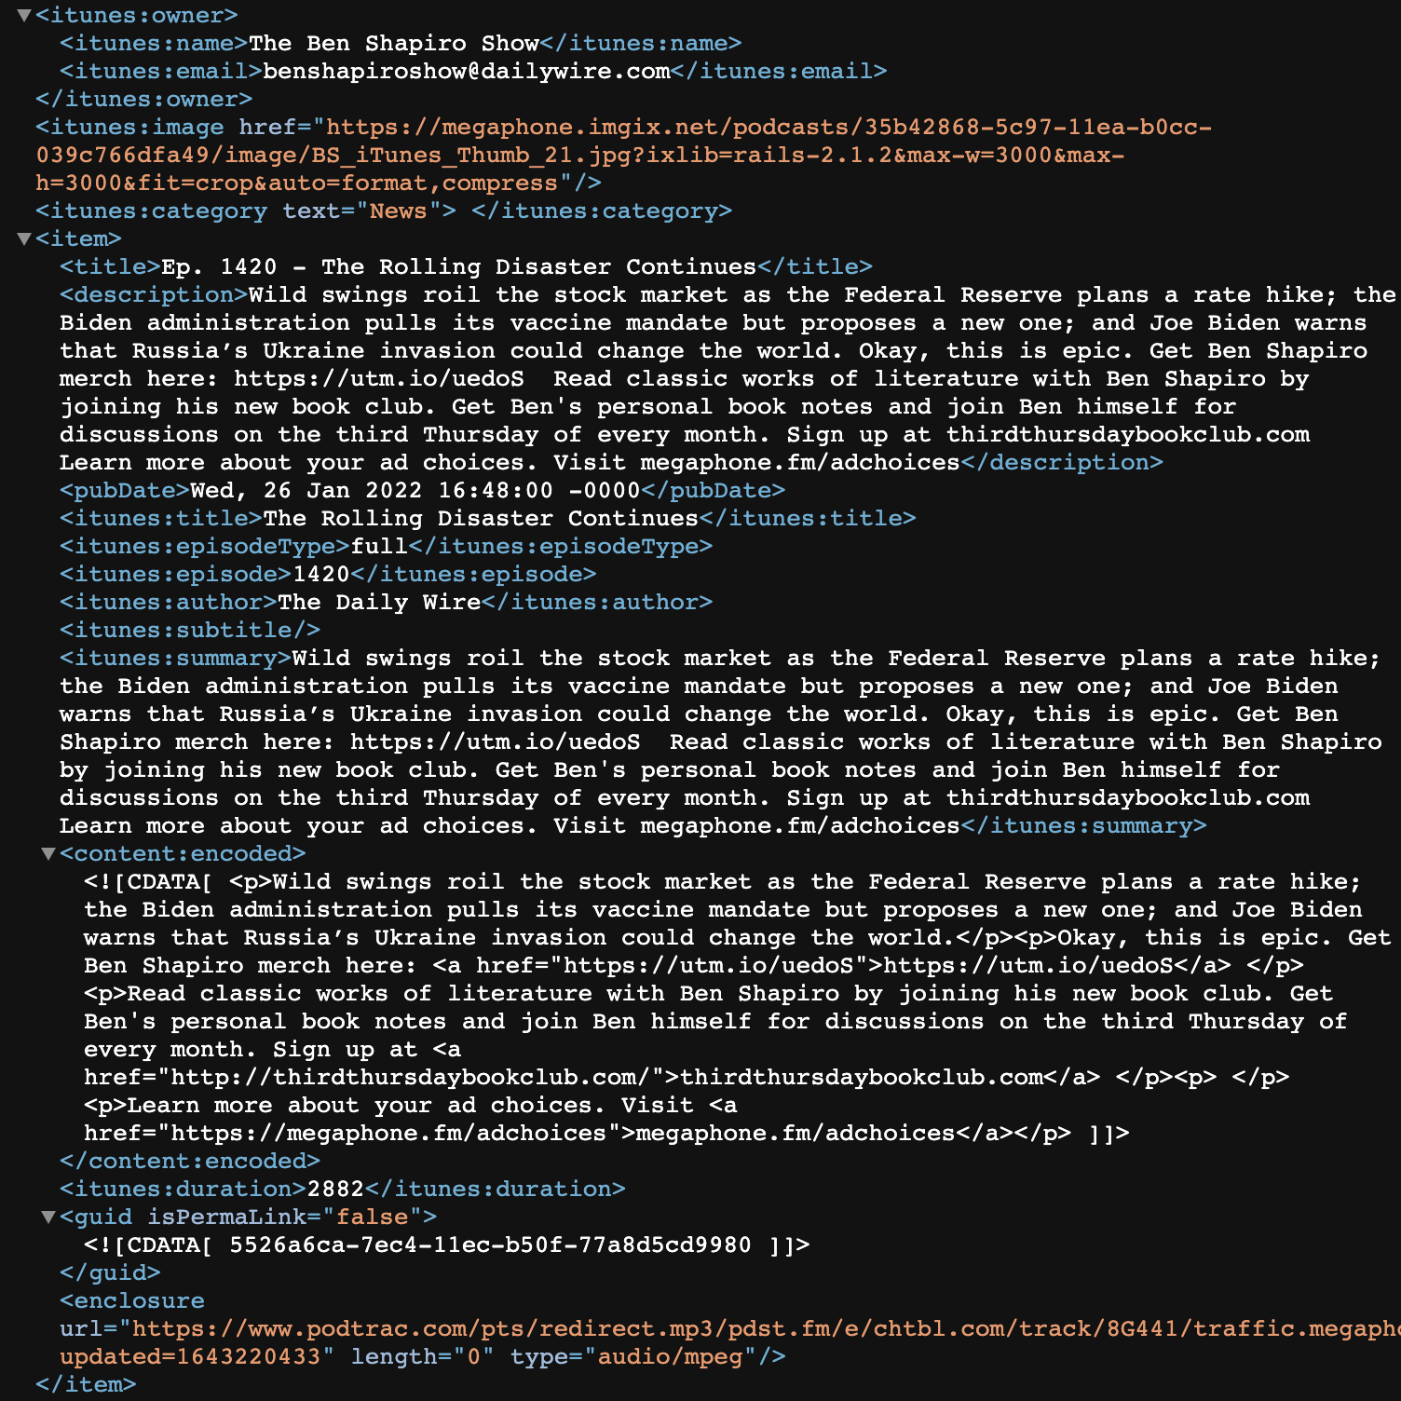

Figure A1 shows what one episode of The Ben Shapiro Show looks like on an RSS feed.

In this example, the tags <item> and </item> bookend the episode, which also includes the episode title, description, publication date, episode number, author, summary, and duration. The mp3 file for this episode is also included at the bottom, under <enclosure url = “URL TO EPISODE FILE” /> Each subsequent episode included in the RSS feed will follow the same format.

After recording an episode, a podcaster will upload episode information to an RSS feed, hosted by a podcast hosting company for a small monthly fee. There are a wide variety of these hosting companies for setting up RSS feeds, but a few of the more commonly used ones are libsyn, podbean and blubrry. For podcasts, information contained in the RSS feed includes data at the episode level, including the publishing date, duration, name, description, and audio file, among other data. This information is stored in a URL, which is then submitted to an RSS reader, like Apple’s Podcast App. Once an RSS feed is approved on an RSS reader, it will automatically update with new episodes unless it is removed or taken down by the owner. While Apple’s Podcast App is one of the most popular RSS readers, only approved podcasts that meet certain submission requirements can be listened to on Apple’s App.[126] Other RSS readers will read any URL that a user passes to them automatically. The general pathway from audio recording to listener is detailed in Figure A2.

**FIGURE A2**



Figure A2 details the process of going from the host recording content to the audience listening to the content.

# Appendix 2: About the Dataset

TABLE A1: Breakdown of series in the dataset

|  |  |  |  |
| --- | --- | --- | --- |
| **Show Name** | **Partisan Ideology** | **Total Episodes** | **Top 100 List?** |
| Bill O’Reilly’s No Spin News and Analysis | More Conservative | 2203 |  |
| The Sean Hannity Show | More Conservative | 2082 | ✓ |
| Bannon’s War Room | More Conservative | 1742 | ✓ |
| The Glenn Beck Program | More Conservative | 1463 | ✓ |
| The Dan Bongino Show | More Conservative | 1307 | ✓ |
| The Daily Show with Trevor Noah | Ears Edition | More Liberal | 1221 | ✓ |
| Mark Levin Podcast | More Conservative | 1185 | ✓ |
| The Andrew Klavan Show | More Conservative | 1142 |  |
| The Ben Shapiro Show | More Conservative | 1121 | ✓ |
| The Matt Walsh Show | More Conservative | 1116 | ✓ |
| Tim Pool Daily Show | Unknown | 1100 | ✓ |
| The Buck Sexton Show | More Conservative | 1077 |  |
| The Michael Knowles Show | More Conservative | 1050 | ✓ |
| Uncle Joey’s Joint | Unknown | 991 |  |
| Conservative Review with Daniel Horowitz | More Conservative | 904 |  |
| The News Why It Matters | More Conservative | 881 |  |
| The Clay Travis and Buck Sexton Show (*previously The Rush Limbaugh Show*) | More Conservative | 869 | ✓ |
| Order Of Man – Protect, Provide, Preside | More Conservative | 801 |  |
| Late Night with Seth Meyers Podcast | More Liberal | 692 |  |
| The Rubin Report | More Conservative | 600 |  |
| Pod Save America | More Liberal | 484 | ✓ |
| The Adam Carolla Show | More Liberal | 480 | ✓ |
| The Axe Files with David Axelrod | More Liberal | 467 |  |
| Political Gabfest | More Liberal | 451 |  |
| Prager-U Five-minute Videos | More Conservative | 428 |  |
| John Solomon Reports | More Conservative | 420 |  |
| Stay Tuned with Preet | More Liberal | 415 |  |
| Unashamed with Phil Jase Robertson | More Conservative | 411 |  |
| Louder with Crowder | More Conservative | 408 | ✓ |
| The Michael Savage Show | More Conservative | 395 |  |
| Jocko Podcast | Unknown | 387 | ✓ |
| Pod Save The World | More Liberal | 363 |  |
| Newt’s World | More Conservative | 356 |  |
| This Past Weekend | Unknown | 347 |  |
| The Bulwark Podcast | More Conservative | 331 |  |
| Pseudointellectual With Lauren Chen | More Conservative | 313 |  |
| The Charlie Kirk Show | More Conservative | 296 | ✓ |
| Get Off My Lawn Podcast with Gavin Mcinnes | Unknown | 270 |  |
| The Fifth Column – Analysis, Commentary, Sedition | Moderate | 262 |  |
| Pod Save The People | More Liberal | 245 |  |
| The Megyn Kelly Show | More Conservative | 245 | ✓ |
| The New Abnormal | More Liberal | 245 |  |
| Federalist Radio Hour | More Conservative | 243 |  |
| Lovett Or Leave It | More Liberal | 232 | ✓ |
| Reasonable Doubt | More Liberal | 228 |  |
| Bret Weinstein | Darkhorse Podcast | More Conservative | 224 | ✓ |
| Fireside Chat with Dennis Prager | More Conservative | 218 |  |
| Hold These Truths with Dan Crenshaw | More Conservative | 217 |  |
| The All New Dennis Miller Option | Unknown | 215 |  |
| Intercepted With Jeremy Scahill | More Liberal | 213 |  |
| Rudy Giuliani's Common Sense | More Conservative | 207 | ✓ |
| Why Is This Happening? with Chris Hayes | More Liberal | 191 |  |
| Your Welcome with Michael Malice | Moderate | 185 |  |
| America First with Sebastian Gorka Podcast | More Conservative | 174 |  |
| Congratulations With Chris D’Elia | Unknown | 174 |  |
| Politicology | Moderate | 170 |  |
| Firebrand with Matt Gaetz | More Conservative | 163 |  |
| With Friends Like These | More Liberal | 159 |  |
| The Jordan B. Peterson Podcast | Unknown | 148 | ✓ |
| Candace | More Conservative | 144 | ✓ |
| The Laura Ingraham Show | More Conservative | 133 |  |
| The MeidasTouch Podcast | More Liberal | 129 |  |
| Majority 54 | More Liberal | 118 |  |
| The Ezra Klein Show | More Liberal | 116 | ✓ |
| Conversations with Coleman | More Liberal | 113 |  |
| The One with Greg Gutfeld | More Conservative | 112 |  |
| Verdict with Ted Cruz | More Conservative | 103 | ✓ |
| Real Time with Bill Maher | More Liberal | 100 | ✓ |
| The Lincoln Project | More Conservative | 95 | ✓ |
| Wtf With Marc Maron Podcast | More Liberal | 87 |  |
| Human Events Daily with Jack Posobiec | More Conservative | 80 |  |
| The Candace Owens Show | More Conservative | 76 | ✓ |
| The National Pulse | More Conservative | 70 |  |
| The Sarah Silverman Podcast | More Liberal | 67 | ✓ |
| The Portal | Moderate | 44 |  |
| Honestly with Bari Weiss | Moderate | 39 |  |
| Common Sense with Dan Carlin | More Liberal | 22 |  |
| The Rachel Maddow Show | More Liberal | 22 | ✓ |
| All In with Chris Hayes | More Liberal | 17 |  |

# Appendix 3: Identifying Unsubstantiated or False Claims

## Broad Analysis

To evaluate the spread of claims fact checked as false across all podcast episodes, I first collected fact checked claims from PolitFact and Snopes. In total, I collected 17,046 fact checks. I include a breakdown by fact check and rating in Figure A3.

**FIGURE A3: Overview of Fact Checked Claims**



To conduct this analysis, I use a strategy that slides a window with a width 30% larger than the length of the fact check (e.g., if the fact check is 90 characters, the window allows for 120 characters) over the entire podcast episode and computes the cosine similarity between the podcast episode window and the fact checked claim. I then return the best match for every fact check across all podcast episodes with a score detailing the quality of the match from 0 to 1 (with zero in this case representing a better match and 1 representing a poor-quality match). I keep only matches with a cosine similarity of .5 or less. I select .5 as the cutoff because above this threshold, the quality of matches begins to deteriorate rapidly. By way of example, consider the fact checked claim below and the associated podcast episode window that triggered a match:

TABLE A2: Example of Cosine Similarity Results

|  |  |
| --- | --- |
| Fact Checked Claim | Podcast Episode Window |
| “you go to a gun show you can buy whatever you want and no background check”[127] | “go you go to a gun show you buy whatever you want no background check no thats completely a lie”[128] |

In this case, the cosine similarly calculation returned a match of .219. However, a wide transcript window and/or manual review of this match reveals that the host is refuting the fact checked claim. As a result, I do *not* code this podcast episode as sharing false information, at least as it pertains to this specific claim. Due to the buffer built into the podcast episode window, no claims will ever be a perfect match, but this buffer may help me identify slight word changes or offer additional context to speed up the manual review.

## Measuring False or Unsubstantiated Claims tied to the 2020 Election

To evaluate the frequency with which political podcasters spread false or unsubstantiated election-related claims, first I subset the data to all episodes that aired between Aug. 20, 2020, when then-candidate Joe Biden accepted the Democratic nomination, and the storming of the Capitol on Jan. 6, 2021. I specify this data range because it demarcates key moments in the 2020 election cycle and offers a picture of both the before and after election conversations tied to the potential for election fraud. Across the 79 series in the dataset, I assess the content from 3,916 episodes in total.

To code podcast episodes, I follow a similar coding strategy detailed in both sections XX and XX. I developed a dictionary of election-fraud related terms, which draws on popular lies, phrases or statistics commonly cited during this period. This includes general terms, like “election fraud” and more detailed terms like “missing usb cards,” a reference to the widely disseminated and debunked narrative that 47 USB cards had gone missing from Pennsylvania voting machines.[129]

I only flag episodes as sharing unsubstantiated or false election-related claims if the episode features any form of editorializing about fraud narratives in a perspective that is designed to cast doubt on the integrity of the election. This includes highlighting the potential credibility or fully endorsing *at least* one claim, spreading any claim (including reading quotes from someone else) without calling into question its veracity *or* featuring a guest who repeats a false claim, without challenging the guest.

Similar to prior coding exercises, two coders worked independently to evaluate whether a podcast episode was sharing unsubstantiated or false election-related claims, based on a match with the key term dictionary. If the two coders disagreed, a third coder adjudicated between their assessments to determine whether the episode shared unsubstantiated or false claims tied to the election or not. All terms used in this key word dictionary can be found in Appendix XX along with detailed coder instructions.

### Election Fraud Terms

The dictionary of terms used in this search draw on popular lies, phrases or statistics commonly referenced during this period. Election fraud related topics include: election fraud, software glitch, counting error, fraudulent biden elector, forensic electronic audit, forensic audit, voter integrity project, illegitimate president, election integrity, stop the steal, stop the steel, thrown out ballots, ditch along a wisconsin road, illegally flipped, missing usb cards, ballot stuffing, election irregularities, hugo chavez, indra, 800000 votes in pennsylvania, out of state license plates, 430 in the morning, venezuelan software, dominion company, 68 error rate, election hoax, surprise ballot dump, dominion systems, smartmatic, 450000 ballots, 3062 instances of voter fraud, stolen election, sharpies, dominion voting, arizona audit, voting machines, duplicate ballots, cyber ninjas, and rigged election.

## Measuring False or Unsubstantiated Claims tied to the Pandemic

Given the complexity of an evolving pandemic, I take a conservative approach toward classifying false and unsubstantiated claims across popular political podcasters. I only flag episodes if they include verifiably false content that either contradicts scientific consensus (e.g., hydroxychloroquine usage could have saved thousands of lives), presents incorrect information (e.g., masks usage will kill you), or generalizes broadly based on anecdotal evidence (e.g., the vaccines cause spontaneous abortions).

To code podcast episodes, I conducted a two-step filtering process to narrow down episodes in the dataset to those using terms or phrases commonly associated with unsubstantiated or false pandemic-related claims. First, I search all transcripts between January 2020 and January 2022 for general terms tied to the pandemic (e.g., coronavirus, pandemic, covid) in order to subset the data to episodes that at least mention the pandemic passingly. Then, using a dictionary of terms related to unsubstantiated or false pandemic-related claims, I filter further to episodes that referenced one or more of these conspiracy or related terms.

As mentioned previously, this dictionary was developed by consulting a wide variety of fact checks, articles and reports detailing specific unsubstantiated or false pandemic-related claims. I then reviewed all episodes that triggered a match with this second dictionary of terms at least once. Any episode that was flagged as sharing unsubstantiated or false pandemic-related claims was evaluated by at least two coders, who also classified these claims as one of the seven categories: (1) alternative treatments/prevention; (2) conspiracies; (3) government policy/response; (4) vaccine efficacy/side effects; (5) company response; (6) disease severity; and (7) testing.

Where guidance changed (e.g., on Hydroxychloroquine usage) I only flag episodes as containing unsubstantiated or false pandemic-related claims after that change occurred. Prior to March 11, when the NBA shut down operations due to the pandemic, I do not flag episodes as containing unsubstantiated or false pandemic-related claims for downplaying disease severity. If an episode shares information that is anecdotal (e.g., my friend had fertility issues after the vaccine) I do not flag that; however, I do flag generalizable statements (e.g., vaccines cause miscarriages). For conspiracies tied to the origins of the coronavirus pandemic, I only focus on those that concern *intentional* release (e.g., the coronavirus was designed to remove Donald Trump from office). I do not code opinions (e.g., I think shutting down schools for coronavirus is not worth it) as unsubstantiated or false pandemic-related claims. While this is undoubtedly a conservative approach, it allows me to guard against the evolving nature of science and the broader shifting trajectory of the pandemic in the coding processes as best as I possibly can. More details on the coding process are provided below.

### Covid Terms Dictionary

To develop a list of episodes focused on false and unsubstantiated COVID claims I relied on two steps. First, I filtered to episodes that contained one or more of the following terms: vaccine|covid|pandemic|coronavirus|kovid|mrna|wuhan. This eliminated episodes from the dataset that might match a term in the COVID dictionary, but not reference in the pandemic, such as the term “fertility” or “bleach”, which could be used in context outside of coronavirus. From there, I developed a dictionary of terms tied to relevant COVID claims, as evaluated on PolitiFact or Snopes, or relevant figures common in vaccine debates.[130] I only include terms based on fact checks that were classified as completely inaccurate. Terms used to identify unsubstantiated or false pandemic-related claims episodes include:

vaers|ivor mechtin|mass formation psychosis| robert malone|peter mccullough|hipaa violation|makeawish foundation|super viruses|mutant variant|plandemic|fort detrick|stolen from a canadian virus research lab|bioengineered|manufactured by the cia|population control|vandana shiva|childrens health defense|forced vaccination|rare brain condition|vaccination information network|prion disease|vaccines cause miscarriages|secret ingredient|weed killer|5g|tracking system|sterilization|roxana bruno|fertility|michael yeadon|robert kennedy|patricia finn|del bigtree|vaccine risk awareness movement|nanochip|microchip|andrew wakefield|suspicious death|millions against medical mandates|organic consumers association|national vaccine information center|megan redshaw|lord fauci|rfk| mercola|charlene bollinger|ty bollinger|tenpenny|rizza islam|rashid buttar|erin elizabeth|sayer ji|kelly brogan|christiane northrup|ben tapper|kevin jenkins|meteor origin|casedemic|benny benassi|bat soup|betty white|bob saget|masks cause|mask are dangerous|vitamin d|vitamin c|common cold|bleach|hydroxychloroquine|ivermectin|miracle mineral supplements|silver infused|zithromax|zinc|more likely to be infected| more likely to be hospitalized|used to kill children|soft tissue cancer diagnos|not safe for pregnant women|more susceptible to hiv| gene therapy|athletes are collapsing|vaccines dont work|saline|spontaneous abortion|guillain barre syndrome| seasonal flu|spike proteins|pandemic of the unvaccinated|quarantine camp|populations growth| population control |undisclosed ingredients|dishonorable discharge|ida evacuees|illegal aliens who were covid positive|high risk people into camps|safer to be unvaccinated|miscarriage rate|never tested in humans|christian eriksen|vaccine related death|creating coronavirus variants|experimental jab|gmo shedding|dmx|pharmacovigilance tracking system|dying of natural causes|female sterilization|more suicide deaths than coronavirus death|improperly counted|doesn’t affect children|children are immune|covid hoax|coronavirus hoax|stella immanuel|toxin inhalation|more illness than it prevents|deadliest vaccine|internment camp|strokes in pilots|parasite|withhold benefits|phony pandemic|undisclosed ingredient|population growth|toxic ingredient|luciferase|rna modifying|track vaccinated|bioweapon|inflated deaths|almost nothing|with not from covid|asymptomatic people cant|difference between the virus and the flu|education camp|national database|court martial|unvaccinated veteran|shut down church|nuremberg code|force vaccinat|vaccines are more dangerous than|stillborn birth|vaccine is not approved

### COVID Claims:

1. Alternative Treatments/Prevention:
   1. Ivermectin treats covid
   2. People are overdosing on ivermectin
   3. Hydroxychloroquine/chloroquine/azithromycin treats covid
2. Conspiracies:
   1. Non-biological components in vaccines (aluminum, undisclosed/secret ingredients, toxic ingredients, luciferase, microchips, nanochips, parasites, etc.)
   2. Vaccines contain RNA/DNA modifying technology (is gene therapy)
   3. Vaccines used to control population growth
   4. Covid outbreak was planned/a plot to beat Donald Trump
   5. London Olympics predicted pandemic
   6. 5g can track vaccinated people
   7. The pandemic is made up
   8. The coronavirus is a bioweapon *intentionally* released by the Chinese government
   9. Some vaccine injections are saline to stagger deaths
   10. mRNA has never been tested in humans
   11. COVID was made at Fort Detrick
   12. COVID was manufactured by the CIA
3. Vaccine Efficacy/Side Effects:
   1. Vaccines kill more people than die of COVID/more dangerous than COVID
   2. Vaccines cause AIDS/cancer/shingles/herpes
   3. Vaccines cause infertility/stillborn births/spontaneous abortions/babies to die from breastfeeding/miscarriages/female sterilization/preterm birth (*Note: this only includes widespread/overarching claims, not individual anecdotes*)
   4. More vaccinated people being hospitalized/dying than unvaccinated
   5. Young people are more likely to be hospitalized for the vaccine than for COVID
   6. Plane crashes linked to vaccine-related strokes
   7. COVID vaccines are causing surge in cases/spreading mutant variants/hospitalizations
   8. Vaccine doesn’t work/increase COVID transmission (*Note: this does not include conversations about waning vaccine immunity/booster necessity*)
   9. Betty White/DMX/Bob Saget/Benny Benassi died of the booster/vaccine
   10. Vaccines will be harmful to those with natural immunity or who were previously infected (*Note: this does not include debates about the quality of natural immunity to prevent infection vis-a-vis vaccines)*
   11. By taking the vaccine, you are enrolled in a medical trial
   12. Vaccines weaken the immune system
4. Disease Severity:
   1. Cloth masks are dangerous/will kill you
   2. Covid deaths are lower than reported/inflated, almost nothing, etc.
   3. Covid is like/no more dangerous than the flu/cold (*Note: this is only coded after the severity of the virus became clear, in this case marked by the shutting down of the NBA season in 2020).*
   4. There are no Omicron hospitalizations
   5. Asymptomatic people can’t spread covid
   6. Covid doesn’t affect children
5. Government Policy/Response:
   1. The government is separating people who are unvaccinated into internment camps/lockdown/education camps (*Note: In Australia, this is only with reference to the general population, not international travelers)*
   2. National database to track unvaccinated
   3. Benefits are being withheld from unvaccinated veterans/unvaccinated veterans are being court martialed/receiving a dishonorable discharge
   4. Withholding government assistance/freezing bank accounts for unvaccinated
   5. Lockdown is designed to permanently shut down churches
   6. Children being separated from parents after testing positive for COVID
   7. Hurricane Ida evacuees being forcibly vaccinated
   8. Violation of Nuremberg code/EU leader called to scrap Nuremberg code
   9. Government will force vaccinate people (*Note: this does not include vaccine mandates for federal employees*)
   10. You can’t get monoclonal antibody treatment if you are white
   11. HIPAA violation for a business to ask about vaccination status
6. Testing:
   1. Testing implants a microchip
   2. Tests can’t tell the difference between the virus and the flu
   3. Tap water is testing positive for COVID

1. LIVE from Miami at YAF’s Freedom Conference | Ep. 65. Accessed September 9, 2022. https://www.youtube.com/watch?v=0Hg1ABSg4L8.
2. Statista. “Number of Podcast Listeners Worldwide 2024.” Accessed September 9, 2022. <https://www.statista.com/statistics/1291360/podcast-listeners-worldwide/?utm_campaign=adtech.podnews.net%3A2022-07-19&utm_medium=email&utm_source=adtech.podnews.net>; TechCrunch. “US Podcast Ad Revenue to Reach $2 Billion in 2022 and Top $4 Billion by 2024, Study Says.” Accessed October 17, 2022. https://techcrunch.com/2022/05/09/u-s-podcast-ad-revenue-to-reach-2-billion-in-2022-and-top-4-billion-by-2024-study-says/.
3. I define “unsubstantiated and false claims” as either claims not backed by evidence at the time they were shared or those that are wholly false. Bond, Shannon. “How Alex Jones Helped Mainstream Conspiracy Theories Become Part of American Life.” NPR, August 6, 2022, sec. National. <https://www.npr.org/2022/08/06/1115936712/how-alex-jones-helped-mainstream-conspiracy-theories-into-american-life>; Washington Post. “Analysis | Joe Rogan Told His Millions of Listeners Not to Take His Anti-Vaccine Advice Seriously. Is It Too Late?” Accessed September 9, 2022. <https://www.washingtonpost.com/politics/2021/05/03/joe-rogan-told-his-millions-listeners-not-take-his-anti-vaccine-advice-seriously-is-it-too-late/>; Dean, Grace. “Joe Rogan Said on His Podcast That Healthy Young People Should Avoid COVID-19 Vaccines. Spotify Reportedly Has No Plans to Remove the Episode.” Business Insider. Accessed September 9, 2022. <https://www.businessinsider.com/joe-rogan-experience-spotify-podcast-covid-vaccine-coronavirus-children-2021-4>.
4. Bottomley, Andrew J. “Podcasting: A Decade in the Life of a ‘New’ Audio Medium: Introduction.” Journal of Radio & Audio Media 22, no. 2 (July 3, 2015): 164–69. https://doi.org/10.1080/19376529.2015.1082880.
5. Wirtschafter, Valerie. “The Challenge of Detecting Misinformation in Podcasting.” Brookings (blog), August 25, 2021. https://www.brookings.edu/techstream/the-challenge-of-detecting-misinformation-in-podcasting/.
6. Guess, Andrew, Jonathan Nagler, and Joshua Tucker. “Less than You Think: Prevalence and Predictors of Fake News Dissemination on Facebook.” Science Advances 5, no. 1 (January 4, 2019): eaau4586. https://doi.org/10.1126/sciadv.aau4586.
7. Hammersley, Ben. “Audible Revolution.” The Guardian, February 12, 2004, sec. Media. https://www.theguardian.com/media/2004/feb/12/broadcasting.digitalmedia.
8. *Ibid.*
9. *Ibid.*
10. Berry, Richard. “Will the IPod Kill the Radio Star? Profiling Podcasting as Radio.” *Convergence: The International Journal of Research into New Media Technologies* 12, no. 2 (May 2006): 143–62. https://doi.org/10.1177/1354856506066522.
11. For more background on the RSS feed, see Appendix 1.
12. Hammersley, “Audible Revolution.”
13. *Ibid.*
14. See <https://www.podcastinsights.com/top-us-podcasts/> for the latest Apple Top 100 list.
15. For more on new media’s role in expanding the scope of who can “be a media outlet,“ see Clay Shirky, *Here comes everybody: The power of organizing without organizations*. Penguin, 2008., pg. 55.
16. Berry, Richard (2016) Podcasting: Considering the evolution of the medium and its association with the word ‘radio’. The Radio Journal International Studies in Broadcast and Audio Media, 14 (1). pp. 7­22. ISSN 1476­4504.
17. Guess, Andrew M., Brendan Nyhan, and Jason Reifler. “Exposure to Untrustworthy Websites in the 2016 US Election.” Nature Human Behaviour 4, no. 5 (May 2020): 472–80. https://doi.org/10.1038/s41562-020-0833-x.; Grinberg, Nir, Kenneth Joseph, Lisa Friedland, Briony Swire-Thompson, and David Lazer. "Fake news on Twitter during the 2016 US presidential election." Science 363, no. 6425 (2019): 374-378.; Osmundsen, Mathias, Alexander Bor, Peter Bjerregaard Vahlstrup, Anja Bechmann, and Michael Bang Petersen. "Partisan polarization is the primary psychological motivation behind political fake news sharing on Twitter." American Political Science Review 115, no. 3 (2021): 999-1015.
18. Radford, Alec. “Introducing Whisper.” *OpenAI*, September 22, 2022. https://openai.com/blog/whisper/.
19. Berry, “Podcasting”.
20. On average, Azure reported an accuracy rate of 75%-80% in their transcriptions, with most errors attributed to the spelling of proper nouns like names or locations. Spiceworks. “Top 10 Speech Recognition Software and Platforms in 2022.” Accessed September 9, 2022. https://www.spiceworks.com/tech/artificial-intelligence/articles/speech-recognition-software/.; On occasion, Azure transcribed words like “Fauci’s role” to ”foul cheese roll.” eric-urban. “How to Use Batch Transcription - Speech Service - Azure Cognitive Services.” Accessed September 9, 2022. https://docs.microsoft.com/en-us/azure/cognitive-services/speech-service/batch-transcription.
21. Google Developers. “Captions | YouTube Data API.” Accessed September 9, 2022. https://developers.google.com/youtube/v3/docs/captions.
22. To identify the political ideology of a show I rely on a method that uses choices about who users follow on Twitter as a measure of political ideology. More details about this method can be found at <https://www.cambridge.org/core/journals/political-analysis/article/birds-of-the-same-feather-tweet-together-bayesian-ideal-point-estimation-using-twitter-data/91E37205F69AEA32EF27F12563DC2A0A> and the R package to implement this process is available here: https://github.com/pablobarbera/twitter_ideology. Where I am unable to identify a political ideology based on this method (i.e., the host doesn’t have a Twitter account or they follow too many or too few people for the information to be meaningful), I use either the known partisan affiliation (e.g., Congressional party affiliation) or classify the show as ''Unknown.” See Appendix 2 for a breakdown of shows by partisan leaning.
23. This strategy for identifying political ideology builds off Pablo Barberá’s 2015 Political Analysis [paper](https://www.cambridge.org/core/journals/political-analysis/article/birds-of-the-same-feather-tweet-together-bayesian-ideal-point-estimation-using-twitter-data/91E37205F69AEA32EF27F12563DC2A0A), which details a method to calculate the political ideology of Twitter users based on decisions about who they choose to follow. The underlying assumption is that Twitter users will often follow accounts that reflect their political interest, which can then be used to develop a measure of their political ideology. In order to ensure the precision of ideology estimates, we exclude users who follow fewer than five “elites” or more than 5,000 accounts. More details on the methodology and implementation can be found [here](https://github.com/pablobarbera/twitter_ideology). Where we are unable to discern partisan leaning through this method or other obvious means (e.g., Congressional party affiliation), we tag the series as "Unknown.”
24. “Twitter by the Numbers (2022): Stats, Demographics & Fun Facts,” February 22, 2022. https://www.omnicoreagency.com/twitter-statistics/.
25. **Hutto, C.J. & Gilbert, E.E. (2014). VADER: A Parsimonious Rule-based Model for Sentiment Analysis of Social Media Text. Eighth International Conference on Weblogs and Social Media (ICWSM-14). Ann Arbor, MI, June 2014.**
26. Han, Jiawei, Micheline Kamber, and Jian Pei. "Getting to know your data." In *Data mining*, vol. 2, pp. 39-82. Boston, MA: Morgan Kaufmann, 2012. This strategy builds on research conducted with coauthors: https://osf.io/preprints/socarxiv/hu4qr.
27. These classifications are described by PolitiFact as follows: (1) MOSTLY FALSE – The statement contains an element of truth but ignores critical facts that would give a different impression; (2) FALSE – The statement is not accurate; and (3) PANTS ON FIRE – The statement is not accurate and makes a ridiculous claim. “PolitiFact - The Principles of the Truth-O-Meter: PolitiFact’s Methodology for Independent Fact-Checking.” @politifact. Accessed September 9, 2022. https://www.politifact.com/article/2018/feb/12/principles-truth-o-meter-politifacts-methodology-i/.
28. Snopes.com. “SharpieGate: Were Trump Ballots Marked with Sharpies Disqualified in Arizona?” Accessed September 9, 2022. https://www.snopes.com/fact-check/sharpie-trump-ballots-arizona/.; See Appendix 3for details on the dictionary of terms and coding steps for this analysis.
29. “PolitiFact - No, Bank of America Didn’t Pledge to Donate $1 Billion to Black Lives Matter.” @politifact. Accessed September 9, 2022. https://www.politifact.com/factchecks/2020/jul/23/facebook-posts/no-bank-america-didnt-pledge-donate-1-billion-blac/.; The Charlie Kirk Show: Chris Bedford | The Coming Rebellion. Accessed September 9, 2022. https://www.youtube.com/watch?v=VoR8wM1tR3E.
30. “PolitiFact - No, Democrats Didn’t Ask for a Steel Barrier, as Donald Trump Said.” @politifact. Accessed September 9, 2022. <https://www.politifact.com/factchecks/2019/jan/09/donald-trump/no-democrats-didnt-ask-steel-wall-donald-trump/>.
31. Apple Podcasts. “‎The Sean Hannity Show: The President Speaks The Truth on Apple Podcasts.” Accessed September 9, 2022. https://podcasts.apple.com/nz/podcast/the-president-speaks-the-truth/id1112194905?i=1000427356794.
32. CBSSports.com. “NBA Suspends Season Due to Coronavirus Outbreak; Owners Preparing for No Games until June, per Report.” Accessed September 9, 2022. https://www.cbssports.com/nba/news/nba-suspends-season-due-to-coronavirus-outbreak-owners-preparing-for-no-games-until-june-per-report/.
33. “TALKERS Magazine - The Top Talk Radio Audiences,” November 14, 2006. https://web.archive.org/web/20061114200439/http://www.talkers.com/main/index.php?option=com_content&task=view&id=17&Itemid=34.
34. “‘TRUMP’S LEGACY & WHY THE LEFT WING GANG IS OUT TO CRUCIFY HIM’ - The Michael Savage Show - Friday July 2, 2021 ⋆ The Savage Nation.” The Savage Nation, July 2, 2021. http://michaelsavage.com/trumps-legacy-why-the-left-wing-gang-is-out-to-crucify-him-the-michael-savage-show-friday-july-2-2021/.
35. “SAVAGE ARCHIVES: WILL IMPEACHMENT CAUSE A RISE OF ANTI-SEMITISM IN THE COUNTRY? ⋆ The Savage Nation.” The Savage Nation, January 22, 2020. https://michaelsavage.com/savage-will-impeachment-cause-a-rise-of-anti-semitism-in-the-country/.
36. Sobieraj, Sarah, and Jeffrey M. Berry. "From incivility to outrage: Political discourse in blogs, talk radio, and cable news." Political Communication 28, no. 1 (2011): 19-41.
37. Cridland, James. “How Many Podcasts Are There?” Podnews, March 10, 2022. https://podnews.net/article/how-many-podcasts.
38. Guess, et. al. “Less than You Think.”
39. Lim, Chloe. "Checking how fact-checkers check." *Research & Politics* 5, no. 3 (2018): 2053168018786848; Nieminen, Sakari, and Valtteri Sankari. "Checking politifact’s fact-checks." *Journalism Studies* 22, no. 3 (2021): 358-378; Card, Dallas, Lucy H. Lin, and Noah A. Smith. "Politifact language audit," *Working Paper* (2018); Louis-Sidois, Charles. “Both Judge and Party? An Analysis of the Political Leaning of Fact-checkers." *Social Science Research Network* (2022); Garrett, R. Kelly, and Robert M. Bond. "Conservatives’ susceptibility to political misperceptions." *Science Advances* 7, no. 23 (2021): eabf1234.
40. The "Non-Election Politics" category includes politically motivated claims that target individual politicians or political parties as opposed to policies or issues. These include claims that Barack Obama is a socialist, Bernie Sanders is a Communist, and Donald Trump bullied a child at an Easter Egg roll, among other more targeted claims. “Election-related claims” focus primarily on campaign falseholds, election fraud and downplaying January 6, 2020. Abortion, healthcare, and COVID-19 were notable themes found in the “Health/Science” category. And claims in the “Crime/Guns” category, focused on discussions about gun procurement laws, violence, and defunding the police.
41. Kessler, Glenn, Salvador Rizzo, and Meg Kelly. "Trump’s False or Misleading Claims Total 30,573 Over 4 Years.” *The Washington Post*, January 24, 2021. https://www.washingtonpost.com/politics/2021/01/24/trumps-false-or-misleading-claims-total-30573-over-four-years/.
42. Hutto and Gilbert, 2014.
43. A version of this analysis was featured in research posted on Brookings’ TechStream blog, but has been updated to include additional episodes that we were able to collect after the initial publication of the research and episodes from other podcasters who were not in Apple’s Top 100 at the time of the 2020 election but are analyzed throughout this report: https://www.brookings.edu/techstream/prominent-political-podcasters-played-key-role-in-spreading-the-big-lie/
44. Steve Bannon’s War Room: Pandemic. “EP 635- Pandemic: For The Republic (w/ Brian Kennedy, Ben Bergquam, John Fredericks and Phil Klein),” January 6, 2021. https://warroom.org/2021/01/06/ep-635-pandemic-w-brian-kennedy-ben-bergquam-john-fredericks-and-phil-klein/.
45. “The Carter Center Releases ‘The Big Lie and Big Tech.’” Accessed September 9, 2022. <https://www.cartercenter.org/news/pr/2021/democracy-big-lie-big-tech-report-100621.html>.; Bond, Shannon, and Bobby Allyn. “How the ‘Stop the Steal’ Movement Outwitted Facebook Ahead of the Jan. 6 Insurrection.” NPR, October 22, 2021, sec. Politics. <https://www.npr.org/2021/10/22/1048543513/facebook-groups-jan-6-insurrection>.; Levy, Steven. “A Trump Ban Is Easy. Fixing Facebook and Twitter Will Be Hard.” Wired. Accessed September 9, 2022. <https://www.wired.com/story/plaintext-trump-ban-easy-fixing-facebook-twitter-hard/>.; Ramachandran, Gowri. “Twitter Is a Cauldron of Misinformation About the Arizona 2020 Vote Audit.” Slate, May 14, 2021. <https://slate.com/technology/2021/05/maricopa-county-arizona-2020-vote-recount-misinformation.html>; Eisenstat, Yaël. “How to Hold Social Media Accountable for Undermining Democracy.” Harvard Business Review, January 11, 2021. <https://hbr.org/2021/01/how-to-hold-social-media-accountable-for-undermining-democracy>; BuzzFeed News. “Facebook Knows It Was Used To Help Incite The Capitol Insurrection.” Accessed September 9, 2022. https://www.buzzfeednews.com/article/craigsilverman/facebook-failed-stop-the-steal-insurrection.; Rattner, Nate. “Trump’s Election Lies Were among His Most Popular Tweets.” CNBC. Accessed September 9, 2022. https://www.cnbc.com/2021/01/13/trump-tweets-legacy-of-lies-misinformation-distrust.html.
46. These numbers include additional episode data I was able to collect after the publication of <https://www.brookings.edu/techstream/prominent-political-podcasters-played-key-role-in-spreading-the-big-lie/>
47. Montanaro, Domenico. “Most Americans Trust Elections Are Fair, but Sharp Divides Exist, a New Poll Finds.” NPR, November 1, 2021, sec. Politics. https://www.npr.org/2021/11/01/1050291610/most-americans-trust-elections-are-fair-but-sharp-divides-exist-a-new-poll-finds.
48. “Key December Dates for the Electoral College | Bipartisan Policy Center.” Accessed September 9, 2022. <https://bipartisanpolicy.org/blog/december-electoral-dates/>; https://www.npr.org/2020/12/11/945617913/supreme-court-shuts-door-on-trump-election-prospects
49. ”Supporting the 2020 U.S. Election.” YouTube Official Blog, December 9, 2020. Accessed October 17, 2022. https://blog.youtube/news-and-events/supporting-the-2020-us-election/.
50. Bond, Shannon and Bobby Allyn. "How the 'Stop the Steal' movement outwitted Facebook ahead of the Jan. 6 insurrection.“ *National Public Radio (NPR)*, October 22, 2021. Accessed October 20, 2022. https://www.npr.org/2021/10/22/1048543513/facebook-groups-jan-6-insurrection.
51. Frenkel, Sheera. “The Rise and Fall of the ‘Stop the Steal’ Facebook Group.” *The New York Times*, November 5, 2020. Accessed October 20, 2022. <https://www.nytimes.com/2020/11/05/technology/stop-the-steal-facebook-group.html.>
52. Vigdor, Neil. ”Twitter flags posts by Trump that made premature claims of victory or baseless ones about election fraud.” *The New York Times*, November 4, 2020. Accessed October 20, 2022. <https://www.nytimes.com/2020/11/04/us/politics/trump-twitter-labels.html>; Gadde, Vijaya, and Kayvon Beykpour. “An update on our work around the 2020 US Elections.“ November 12, 2020. Accessed October 20, 2022. <https://blog.twitter.com/en_us/topics/company/2020/2020-election-update.>
53. Sullivan, Helen. ”'Whoa' – Fox News cuts off Kayleigh McEnany for 'illegal votes' spiel.” *The Guardian*, November 9, 2020. Accessed October 20, 2022. <https://www.theguardian.com/us-news/2020/nov/10/whoa-fox-news-cuts-off-kayleigh-mcenany-for-votes-spiel>; McCarthy, Tom. ”Rupert Murdoch-owned US outlets turn on Trump, urging him to act with 'grace.’” *The Guardian*, November 7, 2020. Accessed October 20, 2022. <https://www.theguardian.com/us-news/2020/nov/07/rupert-murdoch-owned-us-outlets-turn-on-trump-urging-him-to-concede-with-grace>.
54. ” Smartmatic Demands Justice for Defamation.” Smartmatic, December 14, 2020. Accessed October 20, 2022. <https://www.smartmatic.com/us/media/article/smartmatic-demands-justice-for-defamation/>; Breuninger, Kevin. “Election tech company Smartmatic demands retractions from Fox, Newsmax, OAN over conspiracy theories.“ *CNBC*, December 14, 2020. Accessed October 20, 2022. <https://www.cnbc.com/2020/12/14/smartmatic-demands-retractions-from-fox-newsmax-oan.html.>
55. Illing, Sean. “‘Flood the Zone with Shit’: How Misinformation Overwhelmed Our Democracy.” Vox, January 16, 2020. https://www.vox.com/policy-and-politics/2020/1/16/20991816/impeachment-trial-trump-bannon-misinformation.
56. “‎The Sean Hannity Show: Fraud in North Carolina on Apple Podcasts.” Apple Podcasts. Accessed September 9, 2022. https://podcasts.apple.com/us/podcast/fraud-in-north-carolina/id1112194905?i=1000498555808.
57.
58. Michael Knowles. ”What’s Kraken? | Ep. 650.” YouTube, November 23, 2020. Accessed September 9, 2022. https://www.youtube.com/watch?v=Jwj5g-CwOhw.
59. Michael Knowles. ”Schrödinger's POTUS (And Joe Biden’s Cat) | Ep. 653.” YouTube, November 30, 2020. Accessed September 9, 2022. https://www.youtube.com/watch?v=QKcHeiOpOjk.
60. “The Rush Limbaugh Show Podcast - Nov 20 2020 - The Clay Travis and Buck Sexton Show.” IHeart, November 20, 2020. Accessed September 9, 2022. https://www.iheart.com/podcast/1119-travis-and-sexton-57927691/episode/the-rush-limbaugh-show-podcast--74229834/.
61. ”The Holiday Leftovers You Can’t Ignore | Guest: Justin Barclay.” Apple Podcast. Accessed September 9, 2022. https://podcasts.apple.com/qa/podcast/the-holiday-leftovers-you-cant-ignore-guest-justin-barclay/id620967489?i=1000500504374.
62. Steve Bannon‘s War Room: Pandemic. ”Ep 544- Pandemic: Weather the Storm (w/ Jack Posobiec, Rudy Giuliani, Col. Doug Mastriano, and Raymond Ibrahim),” November 28, 2020. https://warroom.org/2020/11/28/ep-544-pandemic/; "The Sean Hannity Show: Fraud in North Caroline on Apple Podcasts.” Apple Podcasts. Accessed September 9, 2022. https://podcasts.apple.com/us/podcast/fraud-in-north-carolina/id1112194905?i=1000498555808; [ affidavit ]; Michael Knowles. ”What’s Kraken? | Ep. 650.” YouTube, November 23, 2020. Accessed September 9, 2022. <https://www.youtube.com/watch?v=Jwj5g-CwOhw>. https://www.youtube.com/watch?v=Jwj5g-CwOhw
63. Michael Knowles. ”Schrödinger's POTUS (And Joe Biden’s Cat) | Ep. 653.” YouTube, November 30, 2020. Accessed September 9, 2022. <https://www.youtube.com/watch?v=QKcHeiOpOjk>; “The Rush Limbaugh Show Podcast - Nov 20 2020 - The Clay Travis and Buck Sexton Show.” IHeart, November 20, 2020. Accessed September 9, 2022. <https://www.iheart.com/podcast/1119-travis-and-sexton-57927691/episode/the-rush-limbaugh-show-podcast--74229834/>; ”The Holiday Leftovers You Can’t Ignore | Guest: Justin Barclay.” Apple Podcast. Accessed September 9, 2022. <https://podcasts.apple.com/qa/podcast/the-holiday-leftovers-you-cant-ignore-guest-justin-barclay/id620967489?i=1000500504374>; Michael Knowles. ”How To Steal An Election | Ep. 641.” YouTube, November 5, 2020. Accessed September 9, 2022. <https://www.youtube.com/watch?v=fiIl8iFoSbw>.
64. A feature on Bannon’s website that purported to track downloads has now been disabled, but as of March 2022, the number stood at 135 million downloads.

    Brandt, Jessica, Valerie Wirtschafter, and Adya Danaditya. “Popular podcasters spread Russian disinformation about Ukraine biolabs.” [Brookings Institution] TechStream (blog), March 23, 2022. Accessed October 20, 2022.

    <https://www.brookings.edu/techstream/popular-podcasters-spread-russian-disinformation-about-ukraine-biolabs/.>
65. ”The Ben Shapiro Show.” Westwood One. https://www.westwoodone.com/programs/news-and-talk/daily-talk/the-ben-shapiro-show/; Drucker, David M.. In Trump's Shadow: The Battle for 2024 and the Future of the GOP. United States: Grand Central Publishing, 2021. https://www.google.com/books/edition/In_Trump_s_Shadow/jpgTEAAAQBAJ?hl=en&gbpv=1&dq=how+many+downloads+per+show+for+ben+shapiro&pg=PT135&printsec=frontcover.
66. Apple Podcasts. “‎The Glenn Beck Program: Bernie’s Communist Revolution Is Coming | Guest: Giancarlo Sopo | 2/24/20 on Apple Podcasts.” Accessed September 9, 2022. https://podcasts.apple.com/us/podcast/bernies-communist-revolution-is-coming-guest-giancarlo/id620967489?i=1000466539909.
67. Apple Podcasts. “‎Conservative Review with Daniel Horowitz: Ep 643 | The Coronavirus Distortions Are a National Scandal on Apple Podcasts.” Accessed September 9, 2022. https://podcasts.apple.com/us/podcast/ep-643-the-coronavirus-distortions-are-a-national-scandal/id1065050908?i=1000475232258.
68. Enders, Adam M., Joseph E. Uscinski, Casey Klofstad, and Justin Stoler. “The Different Forms of COVID-19 Misinformation and Their Consequences.” The Harvard Kennedy School Misinformation Review, November 2020. https://dash.harvard.edu/handle/1/37366466.; Verma, Gaurav, Ankur Bhardwaj, Talayeh Aledavood, Munmun De Choudhury, and Srijan Kumar. “Examining the Impact of Sharing COVID-19 Misinformation Online on Mental Health.” Scientific Reports 12, no. 1 (May 16, 2022): 8045. https://doi.org/10.1038/s41598-022-11488-y. MORE CITATIONS
69. “Health Misinformation — Current Priorities of the U.S. Surgeon General.” Accessed September 9, 2022. https://www.hhs.gov/surgeongeneral/priorities/health-misinformation.
70. Merchant, Raina M., and Nicole Lurie. ”Social Media and Emergency Preparedness in Response to Novel Coronavirus.“ *JAMA*. 2020;323(20): 2011–2012.doi:10.1001/jama.2020.4469; Matteo Cinelli et al. (2020). ”The COVID-19 social media infodemic.“ *Scientific Reports*, 10(1), 16598. <https://ncbi.nlm.nih.gov/pmc/articles/PMC7538912/>; Donovan, Joan. ”Here’s how social media can combat the coronavirus ‘infodemic.‘“ *MIT Technology Review*, March 17, 2020. Accessed October 20, 2022. <https://www.technologyreview.com/2020/03/17/905279/facebook-twitter-social-media-infodemic-misinformation/>; Allem, Jon-Patrick. “Social media fuels wave of coronavirus misinformation as users focus on popularity, not accuracy.“ *The Conversation*, April 6, 2020. Accessed October 20, 2022. <https://theconversation.com/social-media-fuels-wave-of-coronavirus-misinformation-as-users-focus-on-popularity-not-accuracy-135179>.
71. Hsu, Tiffany, and Marc Tracy. “On Podcasts and Radio, Misleading Covid-19 Talk Goes Unchecked.” The New York Times, November 12, 2021, sec. Business. https://www.nytimes.com/2021/11/12/business/media/coronavirus-misinformation-radio-podcasts.html.
72. Bond, Shannon. ”What the Joe Rogan podcast controversy says about the online misinformation ecosystem.” *NPR*, January 21, 2022. Accessed October 20, 2022. <https://www.npr.org/2022/01/21/1074442185/joe-rogan-doctor-covid-podcast-spotify-misinformation>; A recent report by the Tech Transparency Project examined false claims tied to COVID-19 and monkeypox in podcasting but evaluated episodes featuring some of the most severe spreaders of false content: https://www.techtransparencyproject.org/sites/default/files/Apple-Podcast-Report.pdf
73. ”Infodemic.” *World Health Organization*, Accessed September 9, 2022. https://www.who.int/health-topics/infodemic#tab=tab_1.
74. The Lancet Infectious Diseases. "The COVID-19 Infodemic.” *The Lancet* 20, no. 8 (July 2020). https://www.thelancet.com/journals/laninf/article/PIIS1473-3099(20)30565-X/fulltext.
75. Cathey, Libby. "Timeline: Tracking Trump alongside scientific developments on hydroxychloroquine.” *ABC News*, August 8, 2020. https://abcnews.go.com/Health/timeline-tracking-trump-alongside-scientific-developments-hydroxychloroquine/story?id=72170553.
76. Cathey, Libby. "Timeline: Tracking Trump alongside scientific developments on hydroxychloroquine.” *ABC News*, August 8, 2020. https://abcnews.go.com/Health/timeline-tracking-trump-alongside-scientific-developments-hydroxychloroquine/story?id=72170553.
77. *Ibid.*
78. Kirk, Charlie. ”The Charlie Kirk Show: 3 Doctors Speak Out — The Update You Have Been Waiting For.” YouTube video, August 28, 2020. Accessed October 20, 2022. https://youtu.be/Amp4mbm2UIA?t=3352.
79. Michelson, Andrea, and Kieran Press-Reynolds. "Spotify airs Joe Rogan podcast touting ivermectin as part of his COVID-19 treatment, despite the FDA calling it 'dangerous.‘“ *Business Insider,* September 8, 2021. Accessed October 20, 2022. https://www.businessinsider.com/joe-rogan-experience-ivermectin-spotify-covid19-treatment-19-2021-9.
80. https://emergency.cdc.gov/han/2021/pdf/CDC_HAN_449.pdf
81. “America's Frontline Doctors Scotus Press Conference Transcript.” *Rev*, July 28, 2020. https://www.rev.com/blog/transcripts/americas-frontline-doctors-scotus-press-conference-transcript.
82. ”Mark Levin Audio Rewind - 7/28/20.” Audacy, July 29, 2020. https://www.audacy.com/podcasts/mark-levin-podcast-41762/mark-levin-audio-rewind-72820-320221775.
83. Steve Bannon’s War Room. ”Episode 1,040 – The Daszak Files (w/ Natalie Winters, Dr. Peter Navarro).“ June 22, 2021. Accessed September 9, 2022. https://warroom.org/episode-1040-the-daszak-files-w-natalie-winters-dr-peter-navarro; Steve Bannon‘s War Room. “Episode 1,004 – War-Time Footing … How MAGA Candidates and the America First Agenda Will Save the USA.“ June 7, 2021. Accessed September 9, 2022. https://warroom.org/2021/06/07/episode-1004-war-time-footing-how-maga-candidates-and-the-america-first-agenda-will-save-the-usa/.
84. Bret Weinstein. "Covid: The Path not Taken - DarkHorse Podcast with Dr. Peter McCullough.” *YouTube*, December 6, 2021. Accessed September 9, 2022. https://www.youtube.com/watch?v=-zg1j7Zquoc; The Charlie Kirk Show. "MRNA, Microsoft, and the Mark of the Beast? COVID Thought Crimes with Dr. Vladimir Zelenko.” Omny.fm, December 17, 2021. Accessed September 9, 2022. https://omny.fm/shows/the-charlie-kirk-show/mrna-microsoft-and-the-mark-of-the-beast-covid-tho.
85. Steve Bannon’s War Room: Pandemic. ”Episode 1,081 – We are Watching the ’Great Realignment’ (w/ Joe Mobley, Renee, Jack Posobiec),” July 8, 2021. https://warroom.org/2021/07/08/episode-1081-we-are-watching-the-great-realignment/.
86. Steve Bannon’s War Room: Pandemic. ”Episode 1,430 – Waukesha Terrorism And Austria Totalitarianism (w/ Ben Harnwell, Matthew Tyrmand, Naomi Wolf, Debora Blake, Peter Navarro),” November 22, 2021. https://warroom.org/2021/11/22/episode-1430-waukesha-terrorism-and-austria-totalitarianism/.
87. Bret Weinstein. "Bret and Heather 66th DarkHorse Podcast Livestream: All Biology is Evolutionary Biology.“ YouTube, February 6, 2021. Accessed September 9, 2022. https://youtu.be/wndotTtBTZQ?t=4150.
88. PragerU. "Fireside Chat Ep. 216 — Why Does God Allow Bad Things to Happen to Good People?“ YouTube video, December 9, 2021. Accessed October 20, 2022. https://www.youtube.com/watch?v=iSxlKk4YWBI.
89. "Social Blade — Bret Weinstein.” Accessed September 9, 2022. https://socialblade.com/twitter/user/bretweinstein/monthly.
90.
91. ”Social Blade — Heather E Heying.” Accessed September 9, 2022. https://socialblade.com/twitter/user/heathereheying/monthly.
92. Bret Weinstein. ”Bret and Heather 83rd DarkHorse Podcast Livestream: Doing Science in an Emergency.“ YouTube video, June 5, 2021. Accessed October 20, 2022. <https://www.youtube.com/watch?v=pQiv8I9Peqk>; The First. "The Buck Sexton Show | FULL Hour 2 | 09-10-20.“ YouTube video, September 10, 2020. Accessed October 20, 2022. <https://youtu.be/EWtyYaf5h1Q?t=612>.
93. Candace Owens. ”Those Deemed ’Conspiracy Theorists‘ Have Been Right All Along,” June 15, 2021. Accessed September 9, 2022. https://youtu.be/SSDZjosGh1Y?t=202.
94. ”Submission Guide.” medRxiv. Accessed September 9, 2022. https://www.medrxiv.org/submit-a-manuscript.
95. Urman, Aleksandra, et al. “The Politicization of Medical Preprints on Twitter during the Early Stages of COVID-19 Pandemic.” Journal of Quantitative Description: Digital Media, vol. 2, Feb. 2022. journalqd.org, https://journalqd.org/article/view/3007/2447.
96. Cohen, Philip N. “Mexico City’s Program to Distribute Ivermectin to 200,000 COVID-19 Patients, and the Bad Science That Propped It Up.” Family Inequality, February 7, 2022, https://familyinequality.wordpress.com/2022/02/06/mexico-citys-program-to-distribute-ivermectin-to-200000-covid-19-patients-and-the-bad-science-that-propped-it-up/.
97. https://www.science.org/doi/10.1126/sciadv.abd4563
98. ”Fact check: Outdated video of Fauci saying ’there’s no reason to be walking around with a mask.‘” *Reuters*, October 8, 2020. Accessed September 9, 2022. https://www.reuters.com/article/uk-factcheck-fauci-outdated-video-masks/fact-checkoutdated-video-of-fauci-saying-theres-no-reason-to-be-walking-around-with-a-mask-idUSKBN26T2TR.
99.
100. ”IMPEACHMENT: Libs Don't Need FACTS When They Have FEELINGS | The News & Why It Matters | Ep 713.” BlazeTV. Accessed September 9, 2022. https://www.youtube.com/watch?v=l8DwIb_jC5I.
101. Polack, Fernando P., Stephen J. Thomas, Nicholas Kitchin, Judith Absalon, Alejandra Gurtman, Stephen Lockhart, John L. Perez, et al. “Safety and Efficacy of the BNT162b2 MRNA Covid-19 Vaccine.” New England Journal of Medicine 383, no. 27 (December 31, 2020): 2603–15. https://doi.org/10.1056/NEJMoa2034577.
102. https://www.science.org/doi/10.1126/sciadv.abd4563
103. Rosen, Guy. ”An Update on Our Work to Keep People Informed and Limit Misinformation About COVID-19.” Meta, April 16, 2020. [Last updated: May 26, 2021] Accessed October 20, 2022. https://about.fb.com/news/2020/04/covid-19-misinfo-update/#removing-more-false-claims.
104. ”Facebook’s Lab-Leak About-Face,” The Wall Street Journal (The Editorial Board), May 27, 2021. Accessed October 20, 2022. https://www.wsj.com/articles/facebooks-lab-leak-about-face-11622154198.
105. Smitha Khorana and Kellie Owens. “Understanding Medical Uncertainty in the Hydroxychloroquine Debate.” Brookings (blog), July 23, 2020. <https://www.brookings.edu/techstream/understanding-medical-uncertainty-in-the-hydroxychloroquine-debate/>.
106. These recommendations build on those detailed in Valerie Wirtschafter and Chris Meserole. “Policy Recommendations for Addressing Content Moderation in Podcasts.” Brookings (*Techstream*), April 18, 2022. https://www.brookings.edu/techstream/policy-recommendations-for-addressing-content-moderation-in-podcasts/.
107. Nicholas Quah. "Apple might be getting into the podcast-making business. Is its reign as the industry’s benevolent overlord coming to an end?" Nieman Lab, July 16, 2019. Accessed September 9, 2022. https://www.niemanlab.org/2019/07/apple-might-be-getting-into-the-podcast-making-business-is-its-reign-as-the-industrys-benevolent-overlord-coming-to-an-end/.
108.
109. ”Content Policies for Google Search.” Google Search Help. Accessed October 20, 2022. <https://support.google.com/websearch/answer/10622781?hl=en>; ”Search Services.” Yahoo Inc. Accessed October 20, 2022. <https://legal.yahoo.com/us/en/yahoo/privacy/products/searchservices/index.html>; ” Bing Webmaster Guidelines.” Microsoft Bing. Accessed October 20, 2022. <https://www.bing.com/webmasters/help/webmaster-guidelines-30fba23a>.
110. ”Apple Podcasts content guidelines.” *Apple Podcasts for Creators*, Accessed October 17, 2022. https://podcasters.apple.com/support/891-content-and-subscription-guidelines.
111. ”Our Ongoing Work to Tackle Hate.” *YouTube Official Blog*, June 5, 2019. Accessed September 9, 2022. https://blog.youtube/news-and-events/our-ongoing-work-to-tackle-hate/.
112. ”Podcast Statistics and Data [September 2022].” *Buzzsprout*, October 4, 2022. Accessed October 17, 2022. https://www.buzzsprout.com/blog/podcast-statistics.
113. Keller, Daphne. ”Amplification and Its Discontents." *Knight First Institute at Columbia University*, June 8, 2021. Accessed October 17, 2022, https://knightcolumbia.org/content/amplification-and-its-discontents.
114. “Podcast Notes : The Best Ideas from the World’s Best Podcasts in Minutes.” Podcast Notes, Accessed September 9, 2022. https://podcastnotes.org/.
115.
116. Peters, Jay. ”Reddit is adding new real-time features including a live upvote count.” *The Verge*, December 1, 2021. Accessed September 9, 2022. https://www.theverge.com/2021/12/1/22810850/reddit-real-time-live-upvote-reading-typing-indicator-comment; ”Vote Up.” *Stack Overflow*. Accessed September 9, 2022. https://stackoverflow.com/help/privileges/vote-up
117. Menegus, Bryan. "Reddit Is Tearing Itself Apart.” *Gizmodo*, November 29, 2016. Accessed September 9, 2022. https://gizmodo.com/reddit-is-tearing-itself-apart-1789406294.
118. ”Sponsorship Identification Rules.” *Federal Communications Commission*, January 13, 2021. Accessed September 9, 2022. https://www.fcc.gov/consumers/guides/sponsorship-identification-rules.
119. ”Video: Joe Rogan Gets Fact-Checked in Real Time.” CNN Business. Accessed September 9, 2022. https://www.cnn.com/videos/media/2022/01/14/joe-rogan-fact-check-podcast-covid-19-vaccine-newday-vpx.cnn.
120. Jonathan Glick. “Rise of the Platishers.” Vox, February 7, 2014. Accessed September 9, 2022. https://www.vox.com/2014/2/7/11623214/rise-of-the-platishers.
121. ; Carman, Ashley. ”YouTube Offers Up to $300,000 to Get Podcasters to Make Videos.” Bloomberg, March 4, 2022. Accessed September 9, 2022. https:/www.bloomberg.com/news/articles/2022-03-04/youtube-offers-up-to-300-000-to-get-podcasters-to-make-videos.
122. Kastrenakes, Jacob. ”Substack makes a pitch for your podcasts." *The Verge*, April 5, 2022. Accessed September 9, 2022. https://www.theverge.com/2022/4/5/23011365/substack-podcasts-daniel-ek-spotify-parcast-union-negotiations.
123. ”The Decentralized Web.” MIT Digital Currency Initiative. Accessed September 9, 2022. https://dci.mit.edu/decentralizedweb.
124. “RSS.” Encyclopædia Britannica. *Encyclopædia Britannica*, inc. Accessed October 17, 2022. https://www.britannica.com/technology/RSS.
125. ”Spotify 2022 Investor Day Transcript.” Spotify, June 8, 2022. Accessed September 9, 2022. https://storage.googleapis.com/pr-newsroom-wp/1/2022/06/SPOTIFY-2022-INVESTOR-DAY-TRANSCRIPT.pdf?utm_source=podnews.net&utm_medium=email&utm_campaign=podnews.net:2022-06-09.
126. ”Podcast RSS feed requirements.” Apple Podcasts for Creators. Accessed October 17, 2022. https://podcasters.apple.com/support/823-podcast-requirements.
127. “PolitiFact - In Gun Policy Address, Joe Biden Exaggerates about Background Checks at Gun Shows.” @politifact, Accessed September 9, 2022. https://www.politifact.com/factchecks/2021/apr/08/joe-biden/gun-policy-address-joe-biden-was-wrong-about-backg/.
128. ”The Sean Hannity Show: Meet Kathy Barnette on Apple Podcasts.” Apple Podcasts, Accessed September 9, 2022. https://podcasts.apple.com/us/podcast/meet-kathy-barnette/id1112194905?i=1000516370462.
129. Saranac Hale Spencer. "Nine Election Fraud Claims, None Credible.” FactCheck.org, December 11, 2020. Accessed September 9, 2022. https://www.factcheck.org/2020/12/nine-election-fraud-claims-none-credible/.
130. ”Coronavirus.” PolitiFact. Accessed September 9, 2022. https://www.politifact.com/coronavirus/; "COVID-19 Archives.” Snopes, Accessed September 9, 2022. https://www.snopes.com/tag/covid-19/.